Week 1 – Explain one way in which ideas about the treatment of disease were different in the 17th Century from ideas in the 13th Century (4 mark question)
Week 2 – Identify which individuals had the biggest impact on medical care between 1500 and 1700. Explain your choices
Week 3 – Write a paragraph to explain why Harvey’s work did not have much impact when it was first published
Week 4 – Explain one way in which ideas about preventing the plague were different in the 14th and 17th centuries (4 marks)
Week 5 – Create a timeline to show the development of the Germ Theory. Include events from the of both Pasteur and Koch (4 marks)
Week 6 – Write a paragraph explaining how much treatment had changed by c1900
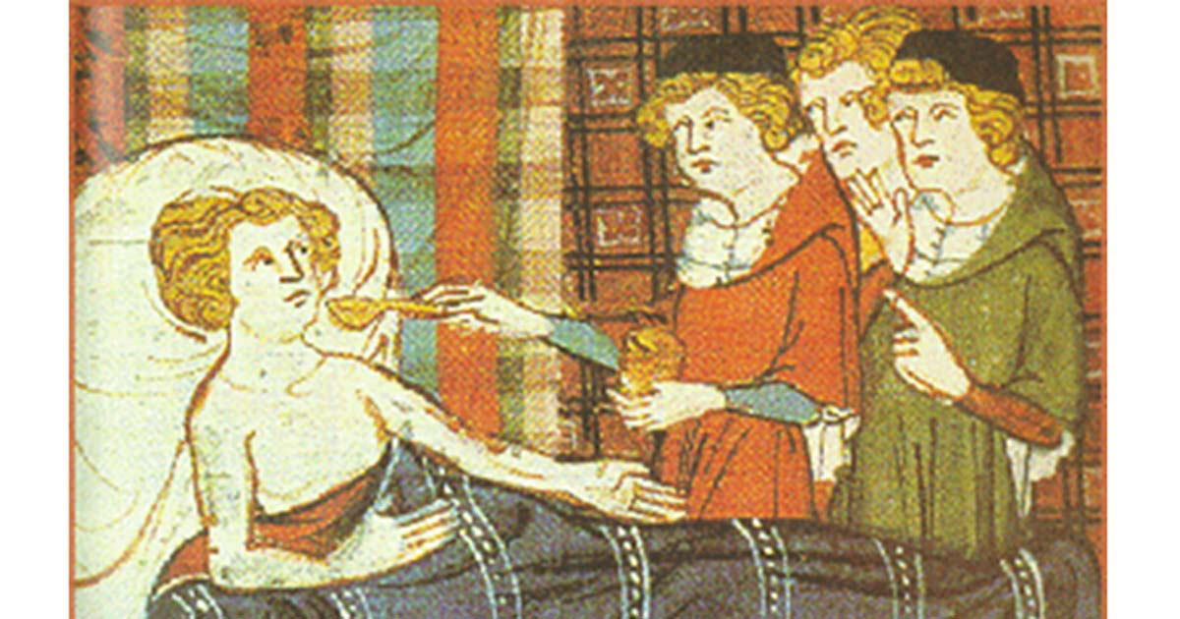
Week 7 – Write an obituary for Florence Nightingale, explaining the impact she had on nursing and hospital design

