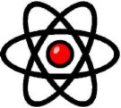
Your School Science Department

5.Energy Changes Mastery Booklet
(Chemistry Paper 1)
Name : ______________________
Teacher : ____________________
Date Given : __________________
These booklets are a consolidation of your learning. They should be used in the following way – You should attempt the questions WITHOUT looking at the answers. Then mark your questions with red pen and add any missing marks you missed. You should then present the completed document to your teacher to show WITHIN TWO weeks of receiving the booklet.
THESE BOOKLETS WILL IMPROVE YOUR GRADES…!!

Q1.
A camping stove uses propane gas.
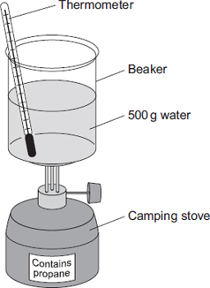
(a) A student did an experiment to find the energy released when propane is burned.
The student:
• put 500 g water into a beaker
• measured the temperature of the water
• heated the water by burning propane for 1 minute
• measured the temperature of the water again.
The student found the temperature change was 20 °C.
The student can calculate the energy released, in joules (J), using the equation:
energy released (J) = mass of water (g) × 4.2 × temperature change (°C)
(i) Use the student’s result to calculate the energy released in joules (J).
______________________________________________________________
______________________________________________________________
Energy released = _________________________ J
(2)
(ii) State two safety precautions that the student should take during the experiment.
1. ____________________________________________________________
______________________________________________________________

2. ____________________________________________________________
______________________________________________________________
(2)
(iii) Tick () two boxes which describe how the student could make his result more accurate.

Tick ()
Stir the water before measuring the temperature.
Heat the water until it boils.
Place a lid on the beaker.
Use a larger beaker for the water.
(2)
(b) The change in energy when propane is burned can be shown in an energy level diagram.
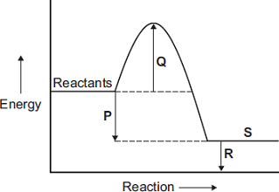
Draw one line from each description to the correct letter.

Description |  | Letter
 |  | P
products
 |  | Q
activation energy
 |  | R
energy released by the reaction
 |  | S
(3)

(c) Propane and hydrogen are both used as fuels.
Some information about propane and hydrogen is given in the table.

Fuel | Resource | Products formed when fuel burned
propane | crude oil | carbon dioxide and water
hydrogen | water | water
Use the information in the table to suggest two disadvantages that propane has as a fuel compared to hydrogen.
1. _________________________________________________________________
___________________________________________________________________
2. _________________________________________________________________
___________________________________________________________________
(2)
(Total 11 marks)
Q2.
Instant cold packs are used to treat sports injuries.
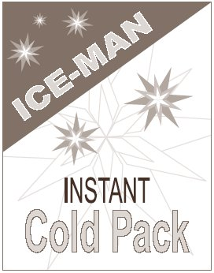
One type of cold pack has a plastic bag containing water. Inside this bag is a smaller bag containing ammonium nitrate.
The outer bag is squeezed so that the inner bag bursts. The pack is shaken and quickly gets very cold as the ammonium nitrate dissolves in the water.

(a) One of the statements in the table is correct.
Put a tick () next to the correct statement.

Statement | ()
The bag gets cold because heat energy is given out to the surroundings.
The bag gets cold because heat energy is taken in from the surroundings.
The bag gets cold because plastic is a good insulator.

(1)
(b) Draw a ring around the word that best describes the change when ammonium nitrate dissolves in water.
electrolysis endothermic exothermic
(1)
(c) Suggest and explain why the pack is shaken after the inner bag has burst.
___________________________________________________________________
___________________________________________________________________
___________________________________________________________________
___________________________________________________________________
(2)
(Total 4 marks)
Q3.
A student investigated the energy change occurring in the endothermic reaction between potassium hydrogencarbonate and hydrochloric acid.
Figure 1 shows the apparatus used.
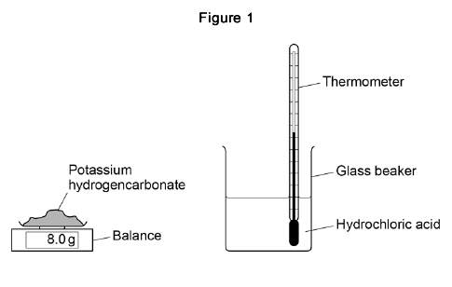
This is the method used.
1. Measure 50 cm³ hydrochloric acid into a glass beaker.
2. Measure 1.0 g of potassium hydrogencarbonate.
3. Add the potassium hydrogencarbonate to the hydrochloric acid.
4. Stir until all the potassium hydrogencarbonate has reacted.
5. Record the lowest temperature reached.
6. Repeat steps 1‒5 two more times.
7. Repeat steps 1‒6 with different masses of potassium hydrogencarbonate.
(a) Which is the most suitable apparatus to use to measure 50 cm³ of hydrochloric acid?
Tick (✔) one box.

Balance
Conical flask
Gas syringe
Measuring cylinder
(1)
(b) The student used a glass beaker for the reaction.
Suggest one change to the apparatus that would improve the accuracy of the results.
Give a reason for your answer.
___________________________________________________________________
___________________________________________________________________
___________________________________________________________________
___________________________________________________________________
(2)

(c) Which two variables should the student keep the same to make this a fair test?
Tick two boxes.

Mass of potassium hydrogencarbonate
Same balance
Same thermometer
Starting temperature of hydrochloric acid
Volume of hydrochloric acid
(2)
(d) Figure 2 shows part of the thermometer used to measure the temperature.
What is the temperature reading on the thermometer?
Temperature = ___________ °C
(1)
The table shows a set of results.

 | Test 1 | Test 2 | Test 3
Lowest temperature in °C | 16.1 | 15.8 | 15.9
(e) What is the range of the lowest temperature?
From _________ °C to _________ °C
(1)

(f) Calculate the mean lowest temperature.
Use the table above.
___________________________________________________________________
___________________________________________________________________
___________________________________________________________________
Mean lowest temperature = ______________________ °C
(2)
(g) How do the results show that the reaction is endothermic?
___________________________________________________________________
___________________________________________________________________
(1)
The graph shows the student’s results.
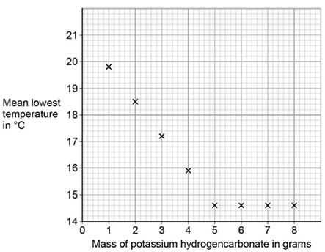
(h) Draw two straight lines of best fit on the graph above.
(2)
(i) Describe how the lowest temperature changes as the mass of potassium hydrogencarbonate added increases.
___________________________________________________________________
___________________________________________________________________
___________________________________________________________________
___________________________________________________________________
___________________________________________________________________
___________________________________________________________________
(3)
(Total 15 marks)
Q4.
This question is about energy changes in chemical reactions.
(a) Complete the word equation for the combustion of hydrogen.
hydrogen + oxygen → ___________________
(1)
(b) Figure 1 shows a simple energy level diagram.
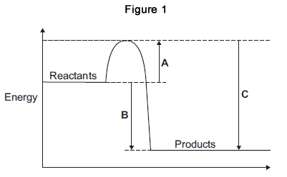
(i) Which arrow, A, B or C, shows the activation energy?

Tick (✔) one box.
A
B
C
(1)
(ii) What type of reaction is shown by the energy level diagram in Figure 1?
Give a reason for your answer.
Type of reaction _________________________________________________
Reason _______________________________________________________
______________________________________________________________
(2)
(iii) For a reaction, the value of A is 1370 kJ and C is 3230 kJ.
Calculate the value of B.
______________________________________________________________
______________________________________________________________
B = _______________________________ kJ
(1)
(c) Alcohols are used as fuels.
A group of students investigated the amount of energy released when different alcohols are burned.
The students used the apparatus shown in Figure 2.
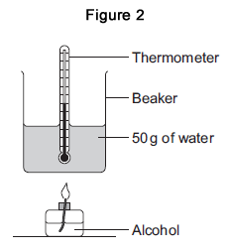
(i) Figure 3 shows the start temperature and the final temperature of the water.
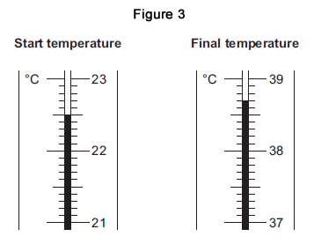
Write the start temperature and the final temperature of the water in Table 1.
Work out the increase in temperature to complete Table 1.

Table 1
Start temperature of the water in °C
Final temperature of the water in °C
Increase in temperature in °C
(3)

(ii) The students worked out the heat energy released by burning 1 g of each alcohol.
The students used the equation:
Heat energy released = m × 4.2 × increase in temperature
Look at Figure 2. What is the value of m?
m = _______________________________ g
(1)
(iii) Table 2 shows the students’ results.

Table 2
Name of alcohol | Number of carbon atoms in one molecule of alcohol | Heat energy released when 1 g of alcohol is burned in kJ
Methanol | 1 | 11.4
Ethanol | 2 | 13.5
Propanol | 3 | 20.1
Butanol | 4 | 16.8
Pentanol | 5 | 17.2
Which value of heat energy released is anomalous?
____________________________________
(1)
(iv) Look at Table 2.
What is the relationship between the number of carbon atoms in one molecule of alcohol and the heat energy released when 1 g of the alcohol is burned?
______________________________________________________________
______________________________________________________________
(1)
(v) The value in a data book for the amount of heat energy released when 1 g of butanol is burned completely is 36.2 kJ.
Suggest two reasons why the students’ result for butanol is lower than the data book value.
1. ____________________________________________________________
______________________________________________________________
2. ____________________________________________________________
______________________________________________________________
(2)

(vi) The displayed structure of butanol is:
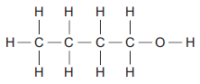
What is the functional group of the alcohol?

Tick (✔) one box.
–– C –– C
–– C –– H
–– O –– H
(1)
(Total 14 marks)
Q5.
Cells contain chemicals which react to produce electricity.
(a) Why can a rechargeable cell be recharged?
___________________________________________________________________
___________________________________________________________________
(1)
(b) Give two factors that affect the voltage produced by a cell.
1. _________________________________________________________________
2. _________________________________________________________________
(2)
(c) Balance the half-equation for the reaction occurring at an electrode in one type of hydrogen fuel cell.
H₂ + OH⁻ ⟶ H₂O + e⁻
(1)
(d) Why is the fuel cell in Question (c) described as an alkaline fuel cell?
___________________________________________________________________
___________________________________________________________________
(1)

(e) Another type of fuel cell uses methanol instead of hydrogen.
The diagram represents the reaction in this fuel cell.
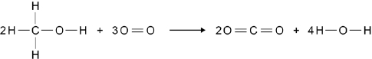
The table shows the bond energies for the reaction.

 | C–H | C–O | O–H | O=O | C=O
Bond energy in kJ / mol | 412 | 360 | 464 | 498 | 805
Calculate the overall energy change for the reaction.
Use the diagram and the table above.
___________________________________________________________________
___________________________________________________________________
___________________________________________________________________
___________________________________________________________________
___________________________________________________________________
___________________________________________________________________
Overall energy change = ____________________ kJ / mol
(3)
(Total 8 marks)
Q6.
Read the information about energy changes and then answer the questions.
A student did an experiment to find the energy change when hydrochloric acid reacts with sodium hydroxide.
The equation which represents the reaction is:
HCl + NaOH → NaCl + H₂O
The student used the apparatus shown in the diagram.
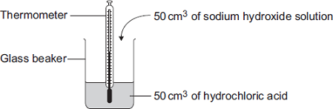
The student placed 50 cm³ of hydrochloric acid in a glass beaker and measured the initial temperature.
The student then quickly added 50 cm³ of sodium hydroxide solution and stirred the mixture with the thermometer. The highest temperature was recorded.
The student repeated the experiment, and calculated the temperature change each time.

 | Experiment 1 | Experiment 2 | Experiment 3 | Experiment 4
Initial temperature  in °C | 19.0 | 22.0 | 19.2 | 19.0
Highest temperature in °C | 26.2 | 29.0 | 26.0 | 23.5
Temperature  change in °C | 7.2 | 7.0 | 6.8 | 4.5
(a) The biggest error in this experiment is heat loss.
Suggest how the apparatus could be modified to reduce heat loss.
___________________________________________________________________
___________________________________________________________________
(1)
(b) Suggest why it is important to mix the chemicals thoroughly.
___________________________________________________________________
(1)
(c) Which one of these experiments was probably done on a different day to the others?
Give a reason for your answer.
___________________________________________________________________
(1)
(d) Suggest why experiment 4 should not be used to calculate the average temperature change.
___________________________________________________________________
___________________________________________________________________
(1)
(e) Calculate the average temperature change from the first three experiments.
___________________________________________________________________
Answer = _________________________ °C
(1)

(f) Use the following equation to calculate the energy change for this reaction.
Energy change in joules = 100 × 4.2 × average temperature change
___________________________________________________________________
Answer = _________________________ J
(1)
(g) Which one of these energy level diagrams represents the energy change for this reaction?
Give a reason for your answer.
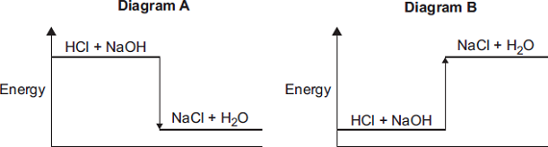
___________________________________________________________________
___________________________________________________________________
(1)
(Total 7 marks)
Q7.
Methanol (CH₃OH) can be made by reacting methane (CH₄) and oxygen (O₂).
The reaction is exothermic.
The equation for the reaction is:
(a) The energy level diagram for this reaction is given below.
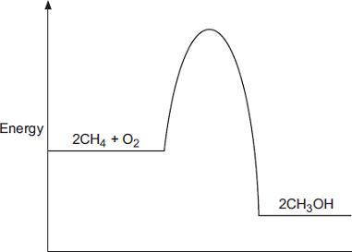
(i) How does the diagram show that this reaction is exothermic?
______________________________________________________________
______________________________________________________________
______________________________________________________________
(1)
(ii) A platinum catalyst can be used to increase the rate of this reaction.
What effect does adding a catalyst have on the energy level diagram?
______________________________________________________________
______________________________________________________________
______________________________________________________________
(1)
(b) The equation can also be written showing the structural formulae of the reactants and the product.
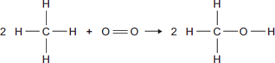
(i) Use the bond energies given in the table to help you to calculate the energy change for this reaction.

Bond | Bond energy in kJ
 | 435
 | 497
 | 336
 | 464
______________________________________________________________
______________________________________________________________
______________________________________________________________
Energy change = ____________________ kJ
(3)
(iii) In terms of the bond energies, why is this an exothermic reaction?
______________________________________________________________
______________________________________________________________
(1)
(Total 6 marks)
Q8.
Some cars are powered by hydrogen fuel cells.
Figure 1
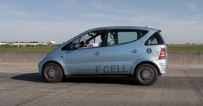
© Robert Couse-Baker (CC BY-SA 2.0) via Flickr
(a) What type of energy is released by hydrogen fuel cells?
___________________________________________________________________
(1)
(b) Owners of cars powered by fuel cells buy hydrogen from hydrogen filling stations.
Figure 2 shows how the number of hydrogen filling stations in the UK is expected to increase up to the year 2030.
Figure 2
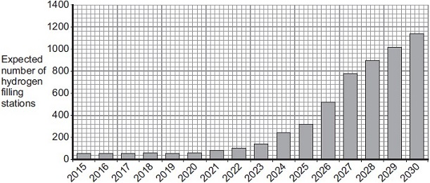
Year
Use the information in Figure 2 and your own knowledge to answer this question.
Suggest two reasons why the UK government might encourage the building of more hydrogen filling stations.
___________________________________________________________________
___________________________________________________________________
___________________________________________________________________
___________________________________________________________________
___________________________________________________________________
(2)
(c) The equation for the reaction of hydrogen with oxygen is:
2 H₂ + O₂ 2 H₂O
During the reaction, energy is used to break the bonds of the reactants.
Energy is released when new bonds are made to form the product.
Bond energies for the reaction are given in the table below.

Bond | Bond energy in kJ
 | 436
 | 498
 | 464
The structures of the reactants and product are shown in Figure 3.
Figure 3
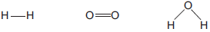

hydrogen | oxygen | water
(i) Calculate the energy change for the reaction:
2 H₂ + O₂ 2 H₂O
______________________________________________________________
______________________________________________________________
______________________________________________________________
______________________________________________________________
______________________________________________________________
______________________________________________________________
Energy change = _______________ kJ
(3)

(ii) The reaction of hydrogen with oxygen is exothermic.
Complete the energy level diagram for this reaction on Figure 4.
Clearly label the activation energy.
Figure 4
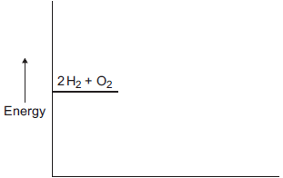
(3)
(Total 9 marks)
Q9.
This question is about energy changes in chemical reactions.
(a) Balance the chemical equation for the combustion of methane.
CH₄ + O₂ → CO₂ + H₂O
(1)
(b) Alcohols are used as fuels.
A group of students investigated the amount of energy released when an alcohol was burned. The students used the apparatus shown in the diagram below.
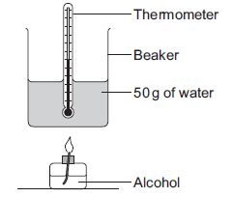
In one experiment the temperature of 50 g of water increased from 22.0 °C to 38.4 °C.
The mass of alcohol burned was 0.8 g.

Calculate the heat energy (Q) in joules, released by burning 0.8 g of the alcohol.
Use the equation:
Q = m × c × ΔT
Specific heat capacity (c) = 4.2 J / g / °C
___________________________________________________________________
___________________________________________________________________
___________________________________________________________________
___________________________________________________________________
Heat energy (Q) = ____________________ J
(3)
(c) The chemical equation for the combustion of ethanol is:
C₂H₅OH + 3O₂ → 2CO₂ + 3H₂O
(i) The equation for the reaction can be shown as:
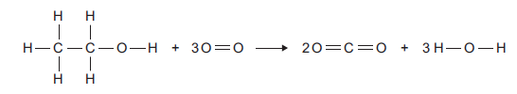

Bond | Bond energy in kJ per mole
C –– H | 413
C –– C | 347
C –– O | 358
C O | 799
O –– H | 467
O O | 495
Use the bond energies to calculate the overall energy change for this reaction.
______________________________________________________________
______________________________________________________________
______________________________________________________________
______________________________________________________________
______________________________________________________________
______________________________________________________________
Overall energy change = ___________ kJ per mole
(3)
(ii) The reaction is exothermic.
Explain why, in terms of bonds broken and bonds formed.
______________________________________________________________
______________________________________________________________
______________________________________________________________
______________________________________________________________
(2)
(iii) Complete the energy level diagram for the combustion of ethanol.
On the completed diagram, label:
• activation energy
• overall energy change.
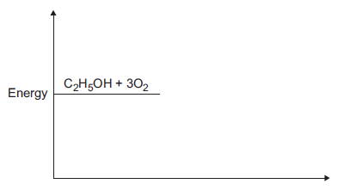
(3)
(Total 12 marks)
Q10.
Methane (CH₄) is used as a fuel.
(a) The displayed structure of methane is:
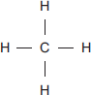
Draw a ring around a part of the displayed structure that represents a covalent bond.
(1)

(b) Why is methane a compound?
Tick () one box.

Methane contains atoms of two elements, combined chemically.
Methane is not in the periodic table.
Methane is a mixture of two different elements.
(1)
(c) Methane burns in oxygen.
(i) The diagram below shows the energy level diagram for the complete combustion of methane.
Draw and label arrows on the diagram to show:
• the activation energy
• the enthalpy change, ΔH.
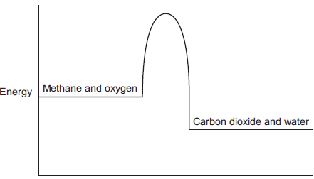
(2)
(ii) Complete and balance the symbol equation for the complete combustion of methane.
CH₄ + _____ CO₂ + _____
(2)
(iii) Explain why the incomplete combustion of methane is dangerous.
______________________________________________________________
______________________________________________________________
______________________________________________________________
______________________________________________________________
(2)
(iv) Explain why, in terms of the energy involved in bond breaking and bond making, the combustion of methane is exothermic.
______________________________________________________________
______________________________________________________________
______________________________________________________________
______________________________________________________________
______________________________________________________________
______________________________________________________________
(3)
(d) Methane reacts with chlorine in the presence of sunlight.
The equation for this reaction is:
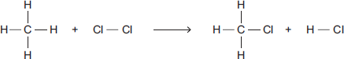
Some bond dissociation energies are given in the table.

Bond | Bond dissociation energy  in kJ per mole
C−H | 413
C−Cl | 327
Cl−Cl | 243
H−Cl | 432
(i) Show that the enthalpy change, ΔH, for this reaction is −103 kJ per mole.
______________________________________________________________
______________________________________________________________
______________________________________________________________
______________________________________________________________
______________________________________________________________
______________________________________________________________
(3)

(ii) Methane also reacts with bromine in the presence of sunlight.
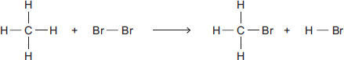
This reaction is less exothermic than the reaction between methane and chlorine.
The enthalpy change, ΔH, is −45 kJ per mole.
What is a possible reason for this?
Tick () one box.

CH₃Br has a lower boiling point than CH₃Cl
The C−Br bond is weaker than the C−Cl bond.
The H−Cl bond is weaker than the H−Br bond.
Chlorine is more reactive than bromine.
(1)
(Total 15 marks)

Q11.
The equation for the reaction of ethene and bromine is:
C₂H₄(g) + Br₂(l) C₂H₄Br₂(l)
The reaction is exothermic.
(a) Complete the energy level diagram.
You should label:
• the activation energy
• the enthalpy change (∆H).
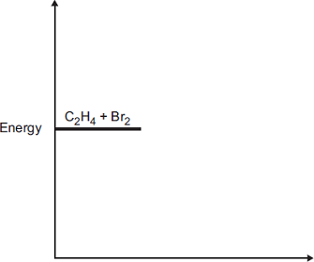
(3)
(b) (i) The equation for the reaction can be represented as:
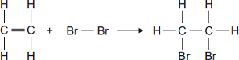

Bond | Bond dissociation energy in kJ per mole
C—H | 413
C ═ C | 614
Br—Br | 193
C—C | 348
C—Br | 276
Use the bond dissociation energies in the table to calculate the enthalpy change (∆H) for this reaction.
______________________________________________________________
______________________________________________________________
______________________________________________________________
______________________________________________________________
______________________________________________________________
______________________________________________________________
Enthalpy change (∆H) = ________ kJ per mole
(3)
(ii) The reaction is exothermic.
Explain why, in terms of bonds broken and bonds formed.
______________________________________________________________
______________________________________________________________
______________________________________________________________
______________________________________________________________
______________________________________________________________
(2)
(Total 8 marks)

Mark schemes
Q1.
(a) (i) 42 000
correct answer gains 2 marks with or without working
allow 42 kJ
if answer incorrect : correct substitution 500 x 4.2 x 20 gains 1 mark
2
(ii) any two from:
• eye protection
• lab coat
• heat-proof mat
• (heat-proof) gloves
• (long) hair tied back
• stand up
• secure the beaker
2
(iii) Stir the water before measuring the temperature.
1
Place a lid on the beaker.
1
(b) the products → S
1
the activation energy → Q
1
the energy released by the reaction → P
1
(c) carbon dioxide produced
it = propane
allow converse arguments
allow greenhouse gas / global warming / atmospheric pollution
(crude oil / propane) non-renewable
1
allow crude oil running out
1
[11]
Q2.
(a) the bag gets cold because heat energy is taken in from the surroundings
1
(b) endothermic
1
(c) any two from:
• mix / spread (the ammonium nitrate and water)
• dissolve faster(*)
• get cold faster or so the whole bag gets cold(*)
(*)allow increase rate or quicker reaction
• particles collide more or more collisions
2
[4]
Q3.
(a) measuring cylinder
1
(b) use a polystyrene cup
allow insulate the beaker and / or use a lid
1
better insulator
or
reduces energy transfer from the surroundings
1
(c) starting temperature of hydrochloric acid
1
volume of hydrochloric acid
1
(d) 21.4 (°C)
1
(e) 15.8 (°C) to 16.1 (°C)
allow 16.1 (°C) to 15.8 (°C)
1
(f) 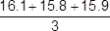
=15.9 (°C)
an answer of 15.9(333..) (°C) scores 2 marks
1
allow 15.9(333..) (°C)
1
(g) temperature decreases
1
(h) straight line from (1.0, 19.8) to (5.0, 14.6)
ignore continuation of line in either direction
1
horizontal straight line from (5.0, 14.6 to 8.0, 14.6)
ignore continuation of line in either direction
1
the answer below scores 2 marks
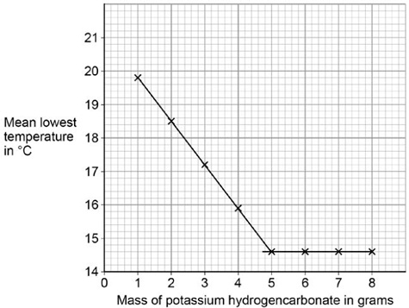
(i) (lowest) temperature decreases
1
to 14.6 °C
or
until 5 g added
1
then no change to temperature (after 5 g solid added)
or
then temperature remains at 14.6 °C (after 5 g solid added)
1
[15]
Q4.
(a) water / H₂O
allow steam or hydrogen oxide
1
(b) (i) A
1
(ii) exothermic
1
products (energy) lower than reactants (energy)
1
(iii) 1860 (kJ)
1
(c) (i) 22.5
1
38.7
1
16.2
allow ecf for correct subtraction
1
(ii) 50 (g)
1
(iii) 20.1 (kJ)
allow propanol
ignore 3
1
(iv) as the number of carbon atoms (in one molecule of alcohol) increases the heat energy given out increases (when the alcohol is burned)
1
(v) any two from:
• no lid
• no insulation
• no draught shield
Allow heat / energy loss to surroundings for any one of these marks
• incomplete combustion
• inaccurate measurement
• no repeats (to calculate a mean)
2
(iv) -O-H
1
[14]
Q5.
(a) the chemical reaction is reversible
1
(b) any two from:
• type of electrode
• electrolyte
• concentration of electrolyte
• temperature
2
(c) H₂ + 2OH⁻ → 2H₂O + 2 e⁻
allow multiples
1
(d) contains OH⁻ ions
1
(e) (bonds broken)
((6 × 412) + (2 × 360) + (2 × 464) + (3 × 498)) = 5614
1
(bonds made)
((4 × 805) + (8 × 464)) = 6932
1
(overall energy change)
(6932 − 5614) = −1318 (kJ / mol)
allow ecf from marking point 1 and / or marking point 2
1
an answer of 1318 (kJ / mol) scores 3 marks
[8]
Q6.
(a) eg plastic (beaker) / insulation / lid / cover or any mention of enclosed
any sensible modification to reduce heat loss
ignore prevent draughts
ignore references to gas loss
ignore bomb calorimeter
1
(b) all the substances react or all (the substances) react fully / completely or heat evolved quickly or distribute heat
‘so they react’ is insufficient for the mark
accept increase chances of (successful) collisions / collision rate increase
do not accept rate of reaction increase / make reaction faster
1
(c) experiment 2 and
different / higher / initial / starting temperature
accept experiment 2 and the room is hotter / at higher temperature
do not accept temperature change / results higher
1
(d) temperature change does not fit pattern
accept anomalous / odd or it is the lowest or it is lower than the others or it is different to the others
‘results are different’ is insufficient
1
(e) 7 / 7.0
1
(f) (100 × 4.2 × 7) = 2940
ecf from (e)
1
(g) diagram A and
reaction exothermic / heat evolved / Δ H is negative / temperature rises
accept energy is lost (to the surroundings)
accept energy of products lower than reactants
allow arrow goes downwards
1
[7]
Q7.
(a) (i) energy / heat of products less than energy of reactants
allow converse
allow products are lower than reactants
allow more energy / heat given out than taken in
allow methanol is lower
allow energy / heat is given out / lost
allow ΔH is negative
1
(ii) lowers / less activation energy
allow lowers energy needed for reaction
or it lowers the peak/ maximum
do not allow just ‘lowers the energy’
1
(b) (i) (8 × 435) + 497 = 3977
accept: bonds broken: (2 × 435) + 497 = 1367
1
(6 × 435) + (2 × 336) + (2 × 464) = 4210
bonds made: (2 × 336) + (2 × 464) = 1600
1
3977 – 4210 = (–) 233
energy change:
1367 – 1600 = (–) 233
ignore sign
allow ecf
correct answer (233) = 3 marks with or without working
1
(ii) energy released forming (new) bonds is greater than energy needed to break (existing) bonds
allow converse
do not accept energy needed to form (new) bonds greater than energy needed to break (existing) bonds
1
[6]
Q8.
(a) electrical
1
(b) using hydrogen saves petrol / diesel / crude oil
allow crude oil is non-renewable
ignore hydrogen is renewable
1
using hydrogen (in fuel cells) does not cause pollution
accept no carbon dioxide produced
allow less carbon dioxide produced
allow hydrogen produces only water
1
(c) (i) (–)486
correct answer with or without working gains 3 marks
if answer is incorrect:
(2 × 436) + 498 or 1370 gains 1 mark
4 × 464 or 1856 gains 1 mark
correct subtraction of ecf gains 1 mark
3
(ii) products lower than reactants
1
reaction curve correctly drawn
1
activation energy labelled
1
[9]
Q9.
(a) CH₄ + 2O₂ → CO₂ + 2H₂O
allow multiples
1
(b) 3444 J
if answer incorrect:
one mark for temperature increase = 16.4 °C
one mark for mass of water = 50 g
ecf for one incorrect value gains two marks for correct calculation
no ecf for two incorrect values
3
(c) (i) 1276 (kJ per mole)
ignore + or -
if answer incorrect:
[(5 × 413) + 347 + 358 + 467] + [(3 × 495)] = 4722 (1 mark)
[(4 × 799) + (6 × 467)] = 5998 (1 mark)
correct subtraction of calculated energy values (1 mark)
3
(ii) because energy released when bonds form is greater than energy used when bonds broken
allow converse
if no mark awarded allow one mark for energy is used to break bonds
or
one mark for energy is released when bonds form
2
(iii) products line lower than reactants
1
activation energy labelled
1
overall energy change labelled
1
[12]
Q10.
(a) circle round any one (or more) of the covalent bonds
any correct indication of the bond − the line between letters
1
(b) Methane contains atoms of two elements, combined chemically
1
(c) (i) activation energy labelled from level of reagents to highest point of curve
ignore arrowheads
1
enthalpy change labelled from reagents to products
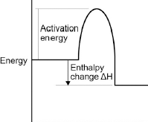
arrowhead must go from reagents to products only
1
(ii) 2 O₂
1
2 H₂O
if not fully correct, award 1 mark for all formulae correct.
ignore state symbols
1
(iii) carbon monoxide is made
1
this combines with the blood / haemoglobin or prevents oxygen being carried in the blood / round body or kills you or is toxic or poisonous
dependent on first marking point
1
(iv) energy is taken in / required to break bonds
accept bond breaking is endothermic
1
energy is given out when bonds are made
accept bond making is exothermic
1
the energy given out is greater than the energy taken in
this mark only awarded if both of previous marks awarded
1
(d) (i) energy to break bonds = 1895
calculation with no explanation max = 2
1
energy from making bonds = 1998
1
1895 − 1998 (= −103)
or
energy to break bonds = 656
energy from making bonds = 759
656 − 759 (= −103)
allow:
bonds broken − bonds made =
413 + 243 − 327 − 432 = -103 for 3 marks.
1
(ii) The C — Br bond is weaker than the C — Cl bond
1
[15]
Q11.
(a) products are at a lower energy level than reactants
if candidate has drawn a profile for an endothermic reaction penalise first marking point only
1
activation energy correctly drawn and labelled
1
ΔH correctly labelled
1
(b) (i) –93 (kJ per mole)
correct answer with or without working gains 3 marks
allow 2 marks for +93 kJ per mole
if any other answer is seen award up to 2 marks for any two of the steps below:
bonds broken (614 + 193) = 807 (kJ) or (614 + 193 + (4 × 413)) = 2459(kJ)
bonds formed (348 + 276 + 276) = 900(kJ) or 348 + (2 × 276) + (4 × 413) = 2552(kJ)
bonds broken – bonds formed
allow ecf for arithmetical errors
3
(ii) more energy is released when the bonds (in the products) are formed
1
than is needed to break the bonds (in the reactants)
if no other marks gained, allow 1 mark for energy released for bond making and energy used for bond breaking
1
[8]

