Please note –

To be used with your purchased revision guide and notes, not instead of!

This is designed to help with your scientific practical skills, **you must know the theory behind each experiment.**

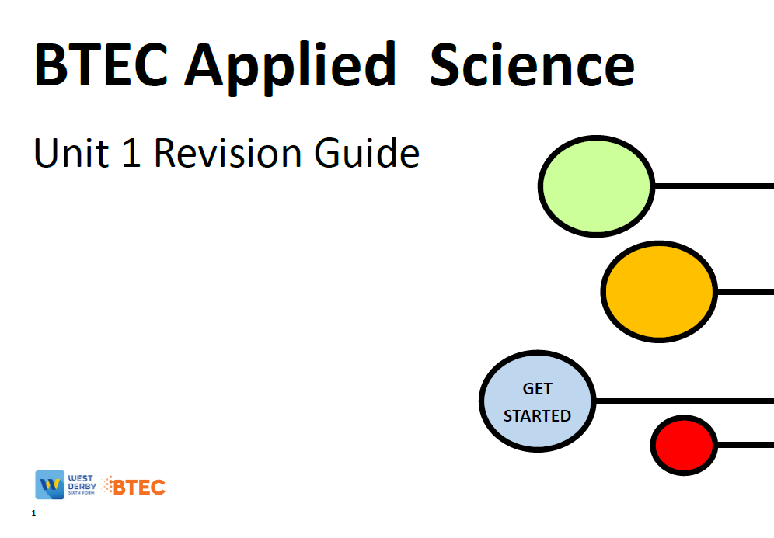

3



Table of Contents

Hypothesis 3

Variables 4

Key terms 5

Percentage Error 6

Correlation 7

Assessment Practice 1 8

Statistical Tests 10

Standard deviation 10

The null hypothesis 15

Chi-squared test 15

Student’s t-test 20

Possible Experiments 27

Section B practice 28

Resources 30

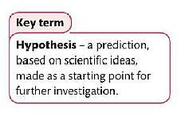Hypothesis

In the exam you will be asked to write a hypothesis.

|  |  |  |
| --- | --- | --- |
| **Level** | **Mark** | **Descriptor** |
| **Level 1** | 1-4 | * Limited attempt at a hypothesis is made |
| **Level 2** | 4-6 | * An explanation for the hypothesis is given which is partially supported by scientific understanding |
| **Level 3 / 4** | 7-12 | * An explanation for the hypothesis is given which is supported by scientific understanding |

Write a hypothesis for the following

1. The effect of pH on enzyme activity.
2. The effect of surface area on the rate of diffusion
3. The effect of light on the growth of plants
4. Different fuels and the amount of energy they release
5. How changing the brightness of the bulb can affect the resistance of a light dependent resistor.

Variables

Which variable is…

The one you change/investigate the effect of –

The one you measure –

Ones you keep the same –

On the graph below, label which variable goes where.

Y

X

Key terms

Define the following terms;

Accuracy –

Precision –

Reliability –

Anomaly –

Mean –

Mode –

Median –

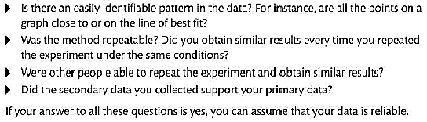

Percentage Error

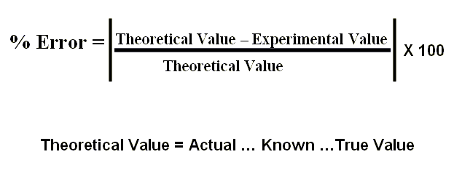

Calculate the percentage error for the following

1. The concentration you calculate is 5 mol, however it is supposed to be 2.

1. The distance the car travels is 10m, however it is supposed to be 15m.
2. You predict that the ball will bounce a height of 5m, it bounces 14.5m.

4) The time taken for the enzyme to denature is 3 mins, 30 seconds, in your experiement it took 5 mins, 45 seconds.

Correlation

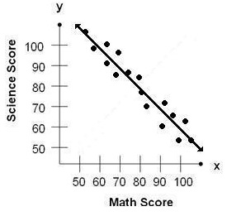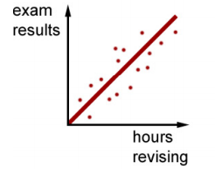

Describe the correlation in these graphs.

Which is positive? Which is negative?

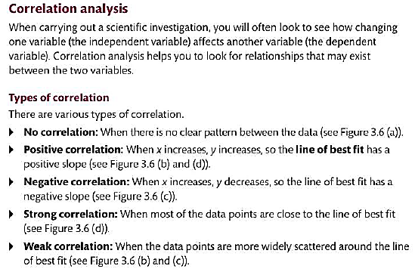

# Assessment Practice 1

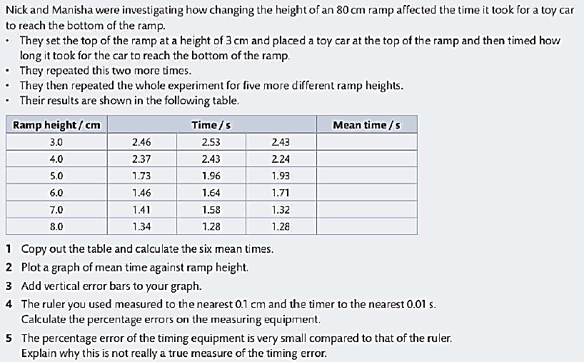Drawing conclusions and evaluations

**Things to consider**

* Is there a relationship between the variables? If so
* Is it positive or negative correlation?
* How strong/weak is the correlation?
* Are the variables proportional?
* Do your results support your hypothesis?

**Evaluation**

* Explain the reason for any anomalous data
* Suggest improvements to your investigation which would make the data more reliable and help to eliminate anomalies.
* Determine the percentage errors of measuring equipment to decide if more precise measuring equipment is needed.

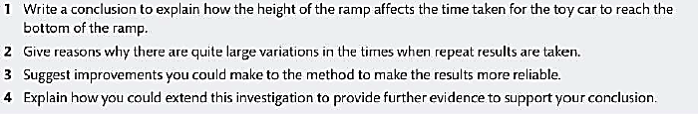**Use the information in assessment practice 1 to answer the following questions**

# Statistical Tests

# Standard deviation

Using standard deviation is better than the range as it **uses all the observations**, and is less affected by the **outliers**.

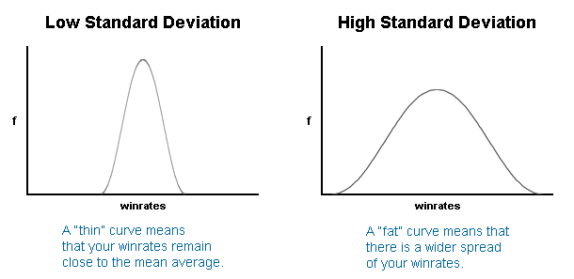

A “thin” curve means that most values remain close to the average, and the standard deviation is small.

A “fat” curve means that there is a wider spread of values about the mean, and the standard deviation is large.

**How to calculate Standard deviation**

The standard deviation is calculated using the formula:

$$SD=√\frac{{Σ\left(x- \bar{x}\right)}^{2}}{n-1}$$

SD = Standard deviation

X = value

x̄ = mean

n = the number of values you have

**± 2 Standard Deviations**

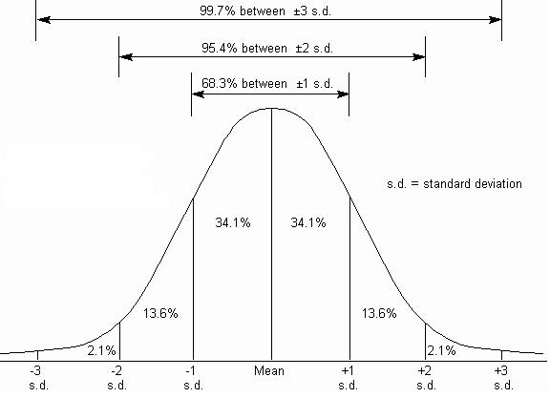

When data has a ‘normal distribution’ as shown in the lovely ‘bell-shaped’ graph above, we can see that **just over 95%** of the data is within two standard deviations either side of the mean. We can make use of this when comparing data.

**± 2 Standard deviations Worked Example**

You have found the following ages of zebras in two different countries. The zebras were randomly selected.

|  |  |
| --- | --- |
| Age of Zebras in South Africa | Age of Zebras in Zimbabwe |
| 36 | 46 |
| 31 | 50 |
| 35 | 48 |
| 24 | 49 |
| 21 | 51 |
| 47 | 49 |

You can use the calculators to calculate the mean and standard deviation

The standard deviation is calculated using the formula:

$$σ=√\frac{{Σ\left(x- \bar{x}\right)}^{2}}{n-1}$$

The best way to show these calculations is in do this is in a table.

|  |  |  |
| --- | --- | --- |
|  | **South Africa** | **Zimbabwe** |
| **mean** | 32.3 | 48.8 |
| **SD** | 9.3 | 1.7 |
| **2 x SD** | 18.6 | 2.4 |
| **Mean + (2 x SD)** | 50.9 | 51.2 |
| **Mean - (2 x SD)** | 13.7 | 46.4 |

**Describing the results**

We can draw a bar chart of the mean and plot the ± 2 Standard deviations from the mean and look at the overlap of the bars.

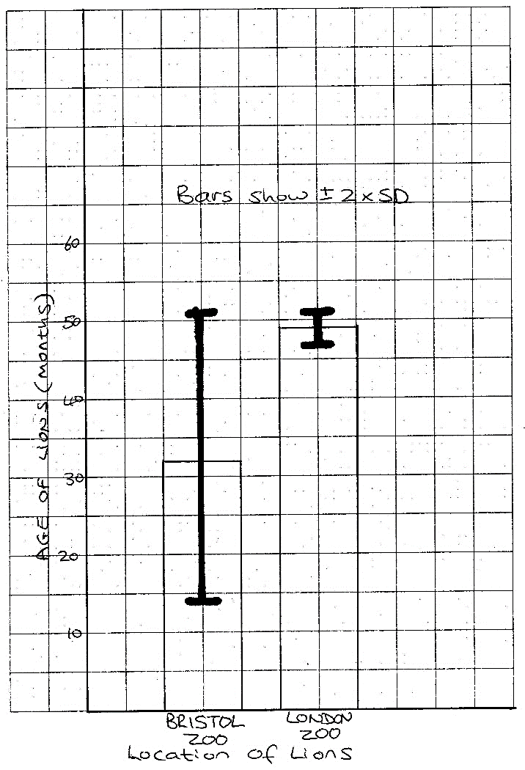

There is an overlap in the (±2 SD) bars.

This indicates that the differences in the means (the age of the Zebras in South Africa and Zebras in Zimbabwe) are **likely** to be due to chance.

Note: You cannot say how ‘likely’ this is due to chance – just that it is likely!

**± 2 Standard deviations Question 1. Heart Rate**

Compare the data for resting heart rate whilst watching two different TV shows. Describe the data.

|  |  |
| --- | --- |
| **Heart rate (beats per min) whilst watching ..** | |
| **Love Island** | **Geordie Shore** |
| 118 | 92 |
| 122 | 156 |
| 126 | 133 |
| 129 | 164 |
| 140 | 145 |
| 141 | 99 |

Now calculate the mean and standard deviation. Use the tables in the resources section to help you!

|  |  |  |
| --- | --- | --- |
|  | **Love Island** | **Geordie Shore** |
| **mean** |  |  |
| **SD** |  |  |
| **2 x SD** |  |  |
| **Mean + (2 x SD)** |  |  |
| **Mean - (2 x SD)** |  |  |

**Describing the results**

Plot the bar chart on graph paper and draw on the 2 x SD bars. You may find you can describe the data without plotting the bar chart though.

There is **an / no** overlap in the (±2 SD) bars.

This indicates that the differences in the means (………………………………..) is **unlikely/likely**  to be due to chance.

**± 2 Standard deviations Question 1. Plant height**

Compare the data for two groups of sunflowers grown in different conditions.

|  |  |
| --- | --- |
| **Height of sunflower (cm)** | |
| **Sun** | **Dark cupboard** |
| 127 | 45 |
| 166 | 55 |
| 144 | 31 |
| 138 | 22 |
| 149 | 43 |
| 153 | 98 |

Now calculate the mean and standard deviation. Use the tables in the resources section to help you!

|  |  |  |
| --- | --- | --- |
|  | **Sun** | **Dark cupboard** |
| **mean** |  |  |
| **SD** |  |  |
| **2 x SD** |  |  |
| **Mean + (2 x SD)** |  |  |
| **Mean - (2 x SD)** |  |  |

**Describing the results**

Plot the bar chart on graph paper and draw on the 2 x SD bars. You may find you can describe the data without plotting the bar chart though.

There is **an / no** overlap in the (±2 SD) bars.

This indicates that the differences in the means (………………………………..) is **unlikely/likely**  to be due to chance.

# The null hypothesis

**What is the null hypothesis (H0)?**

***H*0 = there is no statistically significant difference**

# Chi-squared test

The test looks at the frequencies you obtained when you counted them and compares them with the frequencies you might **expect to get** in order to determine whether the difference is significant or not.

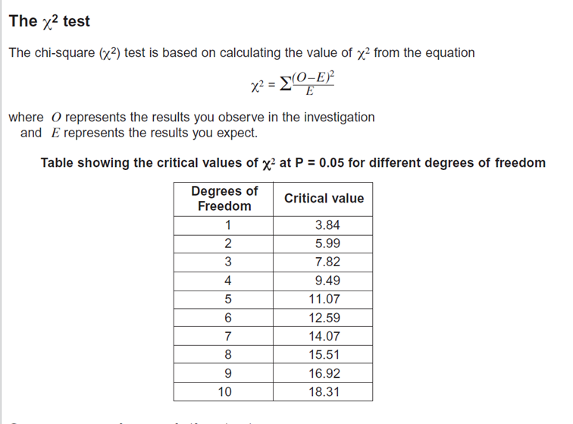

**Chi-squared Worked Example. Birds on scarecrow**

Three farmers have very similar scarecrows in their fields

|  |  |
| --- | --- |
| **Field** | **Observed frequency**  **(the numbers of bird’s visiting the garden on one day in March)** |
| A | 112 |
| B | 145 |
| C | 139 |
| TOTAL | 396 |

**Null hypothesis**

The null hypothesis when doing Chi-squared is

“**there is no significant difference between the observed and expected frequencies**.”

**Expected Frequencies and Calculating the Chi-squared value**

We would expect the same numbers of birds to visit each field if the null hypothesis is correct. A total of 396 birds were seen, so we would expect 132 in each garden (396 ÷ 3)

|  |  |  |  |  |  |
| --- | --- | --- | --- | --- | --- |
| **Garden** | **Observed frequency** | **Expected frequency** | **O-E** | **(O-E)2** | **(O-E)2  E** |
| A | 112 | 132 | -20 | 400 | 3.0 |
| B | 145 | 132 | 13 | 169 | 1.3 |
| C | 139 | 132 | 7 | 49 | 0.4 |
|  | | | | | **χ² = 4.7** |

**Degrees of Freedom**

|  |
| --- |
| **Degrees of freedom = number of categories - 1** |

We have three categories (i.e. three gardens) so the degrees of freedom is 3-1 = **2**

**Interpreting the results**

Looking at the table above we can see that the critical value of Chi-squared at 5% significance (p=0.05) and 2 degrees of freedom is **5.99.**

Our calculated **χ²**value is **4.7**

The calculated value is smaller than the critical value. In a chi-squared test this means we must accept the null hypothesis

Our calculated value of Chi-squared is smaller than the critical value of Chi-squared.

There is more than 5% probability that the differences (between the observed and expected data) are due to chance.

We accept our null hypothesis.

**Chi-squared Question 1. Mendel and his Peas**

Mendel planted some round peas which grew into plants that produced a total of 600 peas. 420 were round peas and 180 were wrinkled peas. Mendel had predicted that he would have 300 round and 300 wrinkled.

**Null hypothesis** Write the null hypothesis here.

…………………………………………………………………………………………………………..

…………………………………………………………………………………………………………..

**Calculating the Chi-squared value**

|  |  |  |  |  |  |
| --- | --- | --- | --- | --- | --- |
| **Shape of pea** | **Observed frequency** | **Expected frequency** | **O-E** | **(O-E)2** | **(O-E)2  E** |
|  |  |  |  |  |  |
|  |  |  |  |  |  |
|  | | | | | χ² **=** |

**Interpreting the results**

How many degrees of freedom are there? ………………

What is the critical value (from the table)? …………………..

Our calculated value of Chi-squared is larger/smaller than the critical value of Chi-squared.

There is more/less than 5% probability that the differences (between the observed and expected data) are due to chance.

We accept/reject our null hypothesis.

**Chi-squared Question 2. A zookeeper’s dilemma**

A zookeeper thinks that increasing the number of climbing frames available in the primate exhibits will reduce the amount of aggression between the baboons. In exhibit A, with extra climbing frames, he observes 45 incidences of aggression over a one month period. In exhibit B, with no climbing frames, he observes 82 incidences of aggression. Does he have enough evidence to support his theory?

**Null hypothesis** Write the null hypothesis here.

…………………………………………………………………………………………………………..

…………………………………………………………………………………………………………..

**Calculating the Chi-squared value**

|  |  |  |  |  |  |
| --- | --- | --- | --- | --- | --- |
|  |  |  |  |  |  |
|  |  |  |  |  |  |
|  |  |  |  |  |  |
|  | | | | |  |

**Interpreting the results**

How many degrees of freedom are there? ………………

What is the critical value (from the table)? …………………..

Our calculated value of Chi-squared is larger/smaller than the critical value of Chi-squared.

There is more/less than 5% probability that the differences (between the observed and expected data) are due to chance.

We accept/reject our null hypothesis.

# Student’s t-test

Use this test when you are looking for the difference between two means, and you want to know if the difference is ‘significant’ or not. OK, so the formula looks a bit scary, but if you look through the worked examples you’ll realise it’s not so tough!

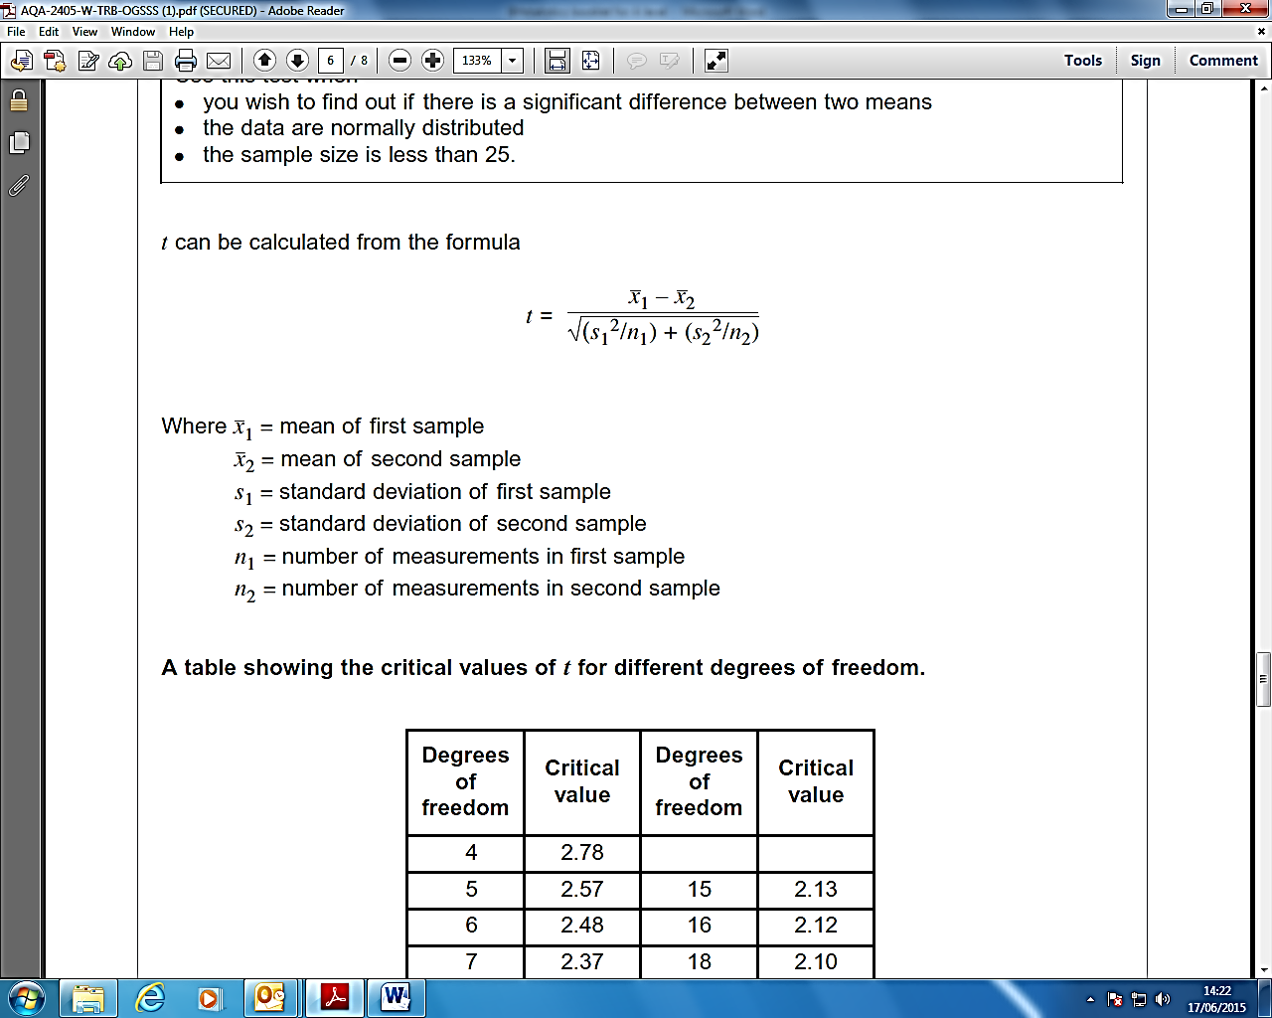

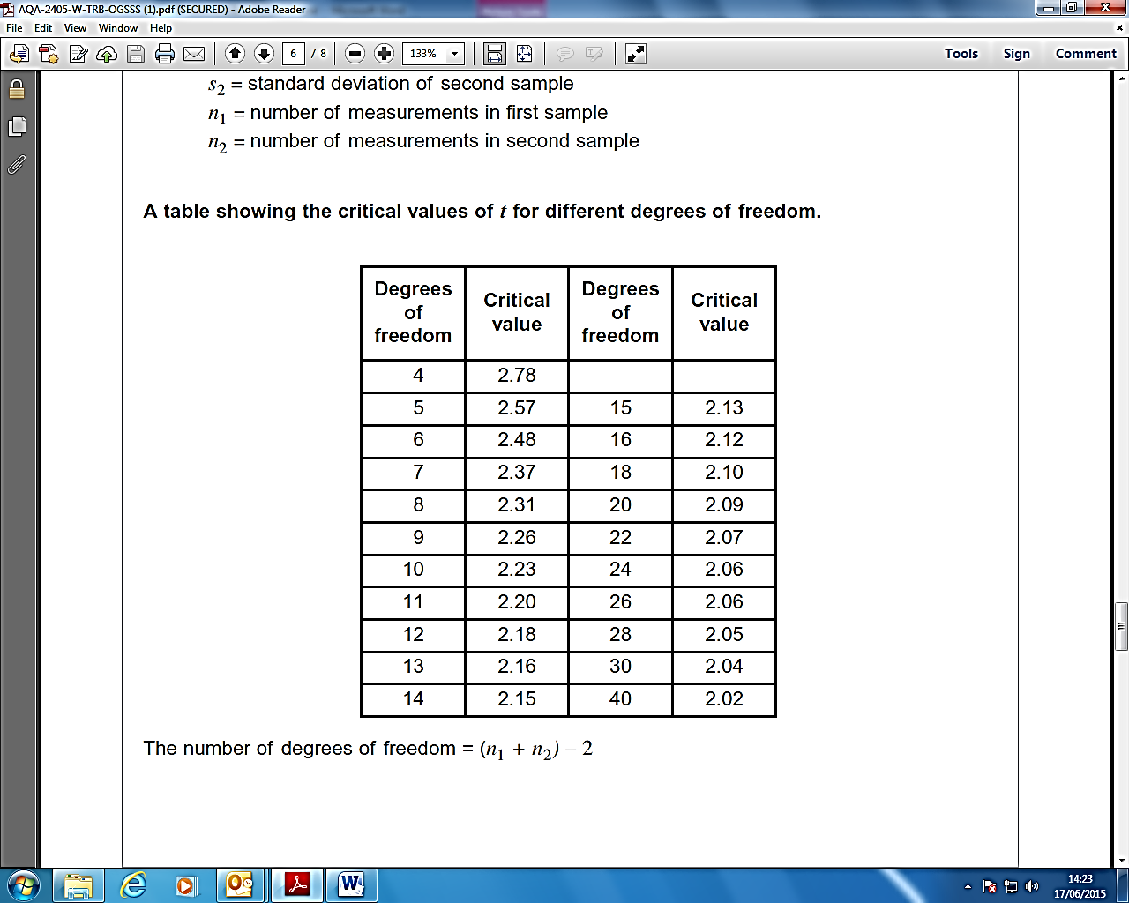

**Student’s t-test Worked Example Fungus**

Miss Smith has been growing two different strains of fungus in flasks. She had 4 replicate flasks for each fungus. We have measured the biomass and want to find out whether or not the results are significantly different for the two fungi..

|  |  |  |
| --- | --- | --- |
|  | **Mass (milligrams) of bacteria** | |
| **Bacterium A** | **Bacterium B** |
| Flask 1 | 520 | 230 |
| Flask 2 | 460 | 270 |
| Flask 3 | 500 | 250 |
| Flask 4 | 470 | 280 |
| **Mean value** | 487.5 | 257.5 |

**Null hypothesis**

The null hypothesis when doing the Student t-test is

“**there is no significant difference between the two different means”**

**Calculating the value of t**

Next we calculate the value of t using the formula below.



The best way to show these calculations is in a table.

|  |  |  |
| --- | --- | --- |
|  | **Fungi A** | **Fungi B** |
| **Mean** | 487.5 | 257.5 |
| **N** | 4 | 4 |
| **s (standard deviation)** | 27.54 | 22.17 |
| **s2** | 758.5 | 491.5 |
| **s2 ÷ n** | 189.6 | 122.9 |

Substitute these values into the formula



t = $\frac{487.5 – 257.5}{√(189.6 +122.9)}$

t = $\frac{230}{√312.5}$

t = $\frac{230}{√17.7}$

t = 12.99

**The ‘critical value’ & the ‘degrees of freedom’**

Before we can interpret our results we need to work out the ‘critical value’. You will remember from Chi-squared that this represents the borderline between accepting or rejecting our null hypothesis. We get the critical value from the data sheet, but this depends on the number of ‘degrees of freedom’. Hopefully you will remember all about 'degrees of freedom' from Chi-squared. The calculation is slightly different simply because it allows for two sets of data.

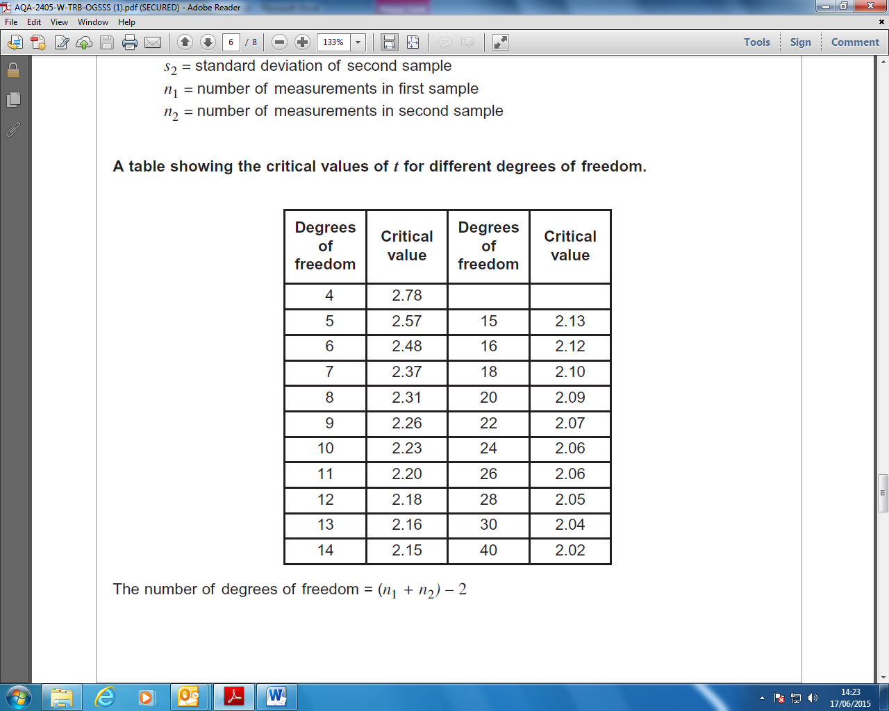

There were 4 flasks for each of the bacteria (n=4 for both bacteria)

Hence:

The number of degrees of freedom = (4 + 4) – 2

The number of degrees of freedom = 6

So we can see from the table of critical values of t, that 6 degrees of freedom = **2.48**

Our value of **t = 12.99** This is much higher than the critical value.

**Interpreting the results**

Our calculated value of t is **greater than** the critical value of t.

There is more than 5% probability that the differences in the means (mean mass of bacterium A and mean mass of bacterium B) are **not** due to chance.

We **reject** our null hypothesis.

**Student’s t-test Question 1.**

A lab technician suspects that his new weighing scales are faulty. He takes readings and compares these with his trusty old bit of kit. His results are in the table below. Are his results significantly different?

|  |  |
| --- | --- |
| **Weighing scales** | |
| **New** | **Old** |
| 15.6 | 15.5 |
| 14.9 | 14.5 |
| 12.4 | 13.8 |
| 15.5 | 15.2 |
| 12.5 | 12.1 |
| 12.5 | 15.3 |

**The Null hypothesis is**

…………………………………………………………………………………………………………

…………………………………………………………………………………………………………

**Calculating the value of t**

|  |  |  |
| --- | --- | --- |
|  | **New expensive kit** | **Old bit of kit** |
| **Mean** |  |  |
| **N** |  |  |
| **s (standard deviation)** |  |  |
| **s2** |  |  |
| **s2 ÷ n** |  |  |

Substitute these values into the formula

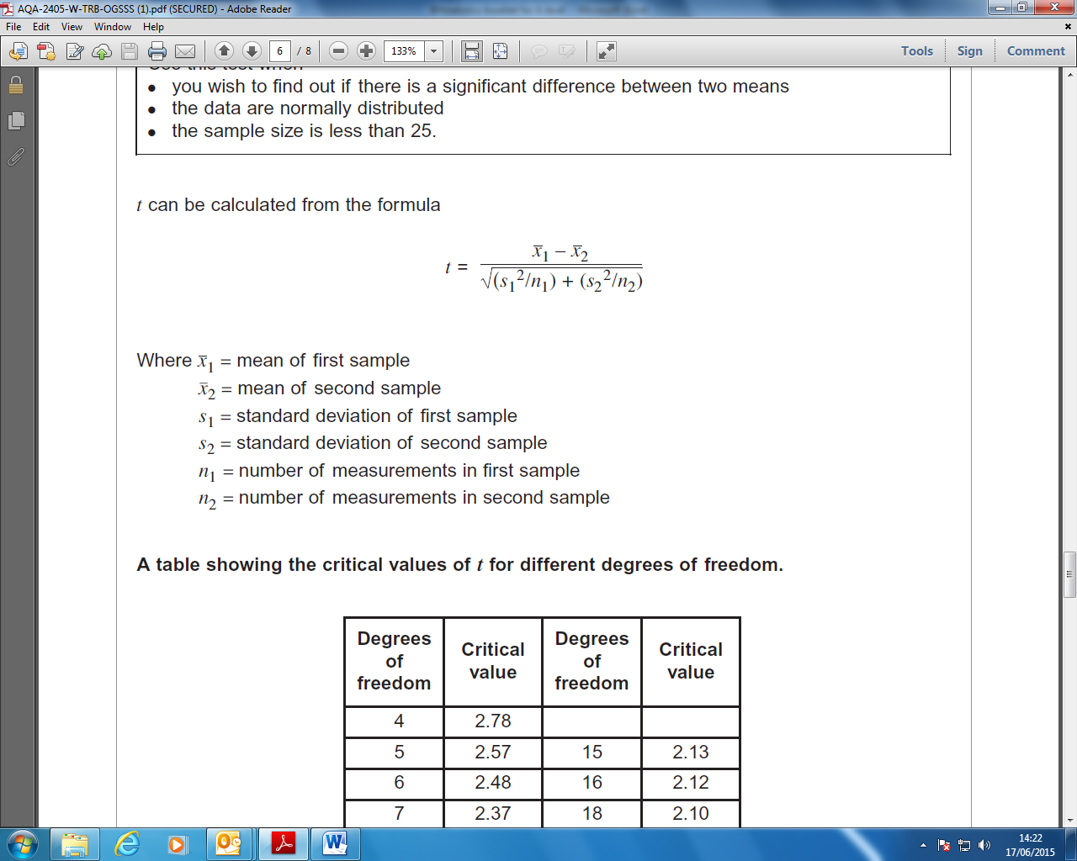

t = $\frac{ - }{\sqrt{( + })}$

t =

t =

t =

**The ‘critical value’ & the ‘degrees of freedom’**

Now calculate how many Degrees of freedom

The number of degrees of freedom = ……………………………

Use the table on the previous page to find the critical values of t = **……………………**

**Interpreting the results**

Our calculated value of t is **less/greater than** the critical value of t.

There is more than 5% probability that the differences in the means (mean mass of bacterium A and mean mass of bacterium B) **are/not** due to chance.

We **accept/reject** our null hypothesis.

**Student’s t-test Question 2.**

A scientist is examining the rate of mitosis in two different garlic cloves

|  |  |
| --- | --- |
| **Time for one cell cycle (hours)** | |
| **Garlic clove A** | **Garlic clove B** |
| 2.6 | 2.1 |
| 3.5 | 1.7 |
| 4.1 | 2.6 |
| 2.8 | 3.8 |
| 2.7 | 3.5 |
| 2.5 | 1.9 |
| 3.1 | 2.1 |
| 2.9 | 2.5 |
| 3.4 | 2.2 |

**The Null hypothesis is**

…………………………………………………………………………………………………………

…………………………………………………………………………………………………………

**Calculating the value of t**

|  |  |  |
| --- | --- | --- |
|  | **Garlic clove A** | **Garlic clove B** |
| **Mean** |  |  |
| **N** |  |  |
| **s (standard deviation)** |  |  |
| **s2** |  |  |
| **s2 ÷ n** |  |  |

Calculate the value of t

The number of degrees of freedom = ……………………………

Use the table on the previous page to find the critical values of t = **……………………**

**Interpreting the results**

Our calculated value of t is **…………………………………………………………………….**

There is …………………………………………………………………………………………………………

We **…………………………………………………………………………………………………………..**

# Possible Experiments

**D Enzymes in action**

* Plan and carry out an investigation to show the effects of temperature and pH on egg albumen.
* Plan an investigation for the effect of substrate concentration on an enzyme-catalysed reaction (catalase and hydrogen peroxide)
* Plan an investigation for the effect of pH on an enzyme-catalysed reaction (amylase on starch)
* Plan an investigation for the effect of temperature on the action of protease on milk

**E Diffusion of molecules**

* Plan an investigation to find the effect of temperature on the rate of diffusion
* Investigate diffusion of food dye through agar practical, using food dye solutions with different concentrations

**F Plants and their environment**

* Plan an investigation to look at the number of daisies in different areas of the campus or in a local park.by and collect data using quadrats.
* Plan an investigation to look at the variation in numbers of a species of plant along the edge of a field.

**G Energy content of fuels**

* Plan an investigation involving heating water using different foods as fuels to see which produces the most energy
* Plan an investigation to find the heat energy produced when burning different candles

**H Electrical circuits**

* Plan an investigation to measure current and voltage for a fixed resistor in a circuit.
* Plan an investigation as to how the resistance of a thermistor varies with temperature
* Plan an investigation using a mains joule meter to find the energy supplied by different appliances in one minute.
* Plan an investigation to find the specific heat capacity of a metal.

# Section B practice

Use the following mark scheme to write a plan for each of these practicals and give it to your teacher to mark.

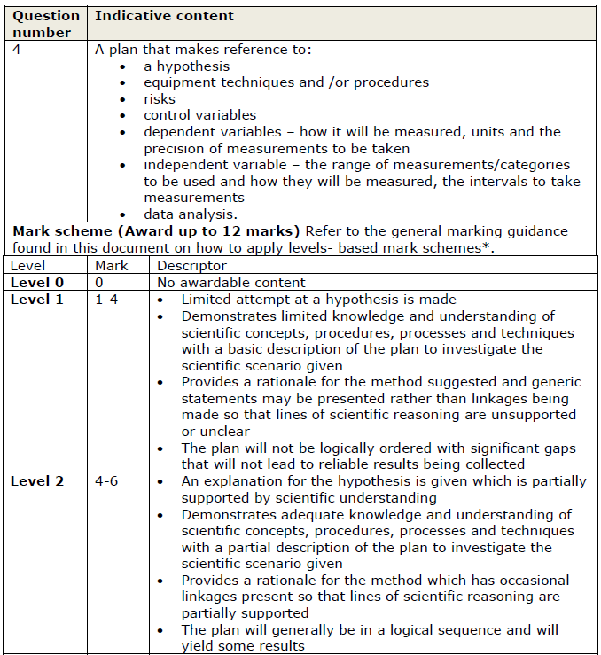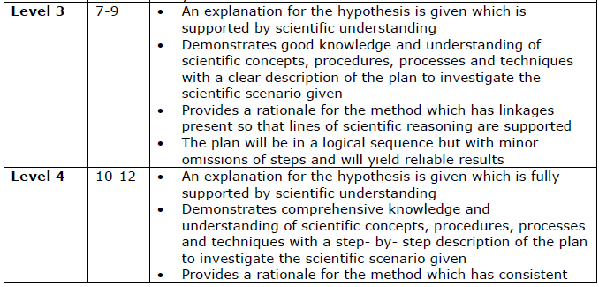

# Resources

$$σ=\sqrt{\frac{\sum{{\left(x_{i}-\overline{x}\right)}^{2}}}{n-1}}$$

|  |  |  |
| --- | --- | --- |
| xi | xi  - x | (xi  - x)2 |
|  |  |  |
|  |  |  |
|  |  |  |
|  |  |  |
|  |  |  |
|  |  |  |
|  |  |  |
|  |  | ∑ |

= Standard deviation

X = value

x̄ = mean

n = the number of values you have

|  |  |  |
| --- | --- | --- |
| xi | xi  - x | (xi  - x)2 |
|  |  |  |
|  |  |  |
|  |  |  |
|  |  |  |
|  |  |  |
|  |  |  |
|  |  |  |
|  |  |  |
|  |  |  |
|  |  | ∑ |

|  |  |  |
| --- | --- | --- |
| xi | xi  - x | (xi  - x)2 |
|  |  |  |
|  |  |  |
|  |  |  |
|  |  |  |
|  |  |  |
|  |  |  |
|  |  |  |
|  |  | ∑ |

= Standard deviation

X = value

x̄ = mean

n = the number of values you have

|  |  |  |
| --- | --- | --- |
| xi | xi  - x | (xi  - x)2 |
|  |  |  |
|  |  |  |
|  |  |  |
|  |  |  |
|  |  |  |
|  |  |  |
|  |  |  |
|  |  |  |
|  |  |  |
|  |  | ∑ |