Your School Science Department

3.Quantititve Chemistry Mastery Booklet
(Chemistry Paper 1)
Name : ______________________
Teacher : ____________________
Date Given : __________________
These booklets are a consolidation of your learning. They should be used in the following way – You should attempt the questions WITHOUT looking at the answers. Then mark your questions with red pen and add any missing marks you missed. You should then present the completed document to your teacher to show WITHIN TWO weeks of receiving the booklet.
THESE BOOKLETS WILL IMPROVE YOUR GRADES…!!

Q1.
This question is about carbon and gases in the air.
(a) Carbon atoms have protons, neutrons and electrons.
Complete the table by writing the relative mass of a neutron and an electron.

Name of particle | Relative mass
proton | 1
neutron
electron
(2)
(b) What is the total number of protons and neutrons in an atom called?

Tick () one box.
The atomic number
The mass number
One mole of the atom
(1)
(c) An atom of carbon has six electrons.
Which structure, A, B or C, represents the electronic structure of the carbon atom?
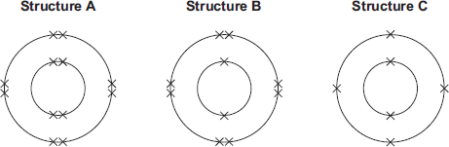

The carbon atom is structure
(1)

(d) Carbon reacts with oxygen to produce carbon dioxide (CO₂).
(i) How many different elements are in one molecule of carbon dioxide?
______________________________________________________________
(1)
(ii) What is the total number of atoms in one molecule of carbon dioxide?
______________________________________________________________
(1)
(e) Sometimes carbon reacts with oxygen to produce carbon monoxide (CO).
(i) Calculate the relative formula mass (M_{r}) of carbon monoxide.
Relative atomic masses (A_{r}): C = 12; O = 16
______________________________________________________________
______________________________________________________________
M_{r} of carbon monoxide = _______________
(1)
(ii) Calculate the percentage by mass of carbon in carbon monoxide.
______________________________________________________________
______________________________________________________________
Percentage by mass of carbon in carbon monoxide = _____%
(1)
(f) Carbon dioxide is one of the gases in the air.
(i) The graph shows the percentage of argon and the percentage of carbon dioxide in the air.
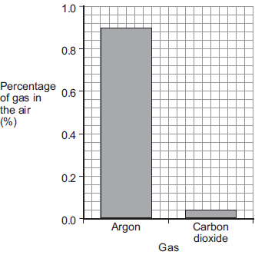
What is the percentage of argon in the air?
Percentage of argon = ____________________ %
(1)
(ii) An instrumental method is used to measure the amount of carbon dioxide in the air.
Give one reason for using an instrumental method.
______________________________________________________________
______________________________________________________________
(1)
(Total 10 marks)
Q2.
Citric acid is a weak acid.
(a) Explain what is meant by a weak acid.
___________________________________________________________________
___________________________________________________________________
___________________________________________________________________
___________________________________________________________________
(2)
A student titrated citric acid with sodium hydroxide solution.
This is the method used.
1. Pipette 25.0 cm³ of sodium hydroxide solution into a conical flask.
2. Add a few drops of thymol blue indicator to the sodium hydroxide solution.
Thymol blue is blue in alkali and yellow in acid.
3. Add citric acid solution from a burette until the end-point was reached.
(b) Explain what would happen at the end-point of this titration.
Refer to the acid, the alkali and the indicator in your answer.
___________________________________________________________________
___________________________________________________________________
___________________________________________________________________
___________________________________________________________________
___________________________________________________________________
___________________________________________________________________
(3)

(c) Explain why a pipette is used to measure the sodium hydroxide solution but a burette is used to measure the citric acid solution
___________________________________________________________________
___________________________________________________________________
___________________________________________________________________
___________________________________________________________________
(2)
(d) The table shows the student’s results.

 | Titration 1 | Titration 2 | Titration 3 | Titration 4 | Titration 5
Volume of citric acid solution in cm³ | 13.50 | 12.10 | 11.10 | 12.15 | 12.15
The equation for the reaction is:
C₆H₈O₇ + 3 NaOH ⟶ C₆H₅O₇Na₃ + 3 H₂O
The concentration of the sodium hydroxide was 0.102 mol / dm ³
Concordant results are those within 0.10 cm ³ of each other.
Calculate the concentration of the citric acid in mol / dm ³
Use only the concordant results from the table in your calculation.
You must show your working.
___________________________________________________________________
___________________________________________________________________
___________________________________________________________________
___________________________________________________________________
___________________________________________________________________
___________________________________________________________________
___________________________________________________________________
Concentration = ____________________ mol / dm ³
(5)
(Total 12 marks)

Q3.
A student investigated the reactions of copper carbonate and copper oxide with dilute hydrochloric acid.
In both reactions one of the products is copper chloride.
(a) Describe how a sample of copper chloride crystals could be made from copper carbonate and dilute hydrochloric acid.
___________________________________________________________________
___________________________________________________________________
___________________________________________________________________
___________________________________________________________________
___________________________________________________________________
___________________________________________________________________
___________________________________________________________________
___________________________________________________________________
(4)
(b) A student wanted to make 11.0 g of copper chloride.
The equation for the reaction is:
CuCO₃ + 2HCl → CuCl₂ + H₂O + CO₂
Relative atomic masses, A_{r}: H = 1; C = 12; O = 16; Cl = 35.5; Cu = 63.5
Calculate the mass of copper carbonate the student should react with dilute hydrochloric acid to make 11.0 g of copper chloride.
___________________________________________________________________
___________________________________________________________________
___________________________________________________________________
___________________________________________________________________
Mass of copper carbonate = _________________________ g
(4)
(c) The percentage yield of copper chloride was 79.1 %.
Calculate the mass of copper chloride the student actually produced.
___________________________________________________________________
___________________________________________________________________
Actual mass of copper chloride produced = ____________ g
(2)

(d) Look at the equations for the two reactions:
Reaction 1 CuCO₃(s) + 2HCl(aq) → CuCl₂(aq) + H₂O(l) + CO₂(g)
Reaction 2 CuO(s) + 2HCl(aq) → CuCl₂(aq) + H₂O(l)
Reactive formula masses: CuO = 79.5; HCl = 36.5; CuCl₂ = 134.5; H₂O = 18
The percentage atom economy for a reaction is calculated using:
Calculate the percentage atom economy for Reaction 2.
___________________________________________________________________
___________________________________________________________________
___________________________________________________________________
___________________________________________________________________
___________________________________________________________________
___________________________________________________________________
Percentage atom economy = ________________________ %
(3)
(e) The atom economy for Reaction 1 is 68.45 %.
Compare the atom economies of the two reactions for making copper chloride.
Give a reason for the difference.
___________________________________________________________________
___________________________________________________________________
(1)
(Total 14 marks)
Q4.
Cobalt forms coloured compounds.
A pink cobalt compound reacts with hydrochloric acid.
The reaction can be represented as:
pink cobalt compound + hydrochloric acid ⇌ blue cobalt compound + water
The forward reaction is endothermic.
When both cobalt compounds are present in a solution at equilibrium, the equilibrium mixture is purple.

(a) What is meant by equilibrium?
___________________________________________________________________
___________________________________________________________________
___________________________________________________________________
___________________________________________________________________
(2)
(b) The equilibrium mixture is cooled.
Explain what happens to the concentration of the pink cobalt compound.
___________________________________________________________________
___________________________________________________________________
___________________________________________________________________
___________________________________________________________________
___________________________________________________________________
___________________________________________________________________
(3)
(c) More hydrochloric acid is added.
Explain what happens to the colour of the equilibrium mixture
___________________________________________________________________
___________________________________________________________________
___________________________________________________________________
___________________________________________________________________
___________________________________________________________________
___________________________________________________________________
(3)
(d) Why does cobalt form different coloured compounds?
___________________________________________________________________
(1)

(e) An oxide of cobalt has the formula Co₂O₃
Which cobalt ion is present in this oxide?
Tick (✔) one box.

Co⁺
Co²⁺
Co³⁺
Co⁴⁺
(1)
(f) Cobalt compounds can act as catalysts.
Which two statements about cobalt compounds are correct?
Tick (✔) two boxes.

They allow reactions to reach equilibrium more quickly.
They are reactants in reactions catalysed by cobalt compounds.
They are used up when acting as catalysts.
They increase the equilibrium yield of reactions.
They provide a different reaction pathway.
(2)
(g) The reaction of hydrogen with carbon monoxide is catalysed by cobalt metal.
Balance the equation for the reaction.
H₂ + CO ⟶ C₆H₁₄ + H₂O
(1)
(h) C₆H₁₄ is an alkane.
What is the formula of an alkane containing 18 hydrogen atoms?
__________________________________
(1)
(i) The graph shows a reaction profile diagram for a reaction without a catalyst.
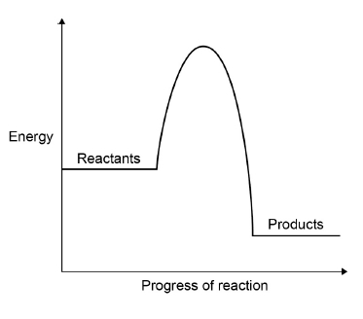
On the graph:
• draw the reaction profile diagram for a catalysed reaction
• draw and label an arrow to show the activation energy for the reaction without a catalyst.
(2)
(Total 16 marks)
Q5.
Some students were investigating the rate at which carbon dioxide gas is produced when metal carbonates react with an acid.
One student reacted 1.00 g of calcium carbonate with 50 cm³, an excess, of dilute hydrochloric acid.
The apparatus used is shown in Diagram 1.
Diagram 1
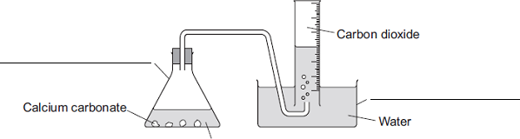
Dilute hydrochloric acid
(a) Complete the two labels for the apparatus on the diagram.
(2)

(b) The student measured the volume of gas collected every 30 seconds.
The table shows the student’s results.

Time in  seconds | Volume of carbon dioxide  collected in cm³
30 | 104
60
90 | 198
120 | 221
150 | 232
180 | 238
210 | 240
240 | 240
(i) Diagram 2 shows what the student saw at 60 seconds.
Diagram 2
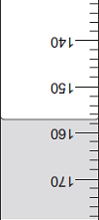
What is the volume of gas collected?
Volume of gas = __________ cm³
(1)
(ii) Why did the volume of gas stop changing after 210 seconds?
______________________________________________________________
______________________________________________________________
(1)

(c) Another student placed a conical flask containing 1.00 g of a Group 1 carbonate (M₂CO₃) on a balance.
He then added 50 cm³, an excess, of dilute hydrochloric acid to the flask and measured the mass of carbon dioxide given off.
The equation for the reaction is:
M₂CO₃ + 2HCl 2MCl + H₂O + CO₂
The final mass of carbon dioxide given off was 0.32 g.
(i) Calculate the amount, in moles, of carbon dioxide in 0.32 g carbon dioxide.
Relative atomic masses (A_{r}): C = 12; O = 16
______________________________________________________________
______________________________________________________________
______________________________________________________________
Moles of carbon dioxide = __________ moles
(2)
(ii) How many moles of the metal carbonate are needed to make this number of moles of carbon dioxide?
______________________________________________________________
______________________________________________________________
Moles of metal carbonate = __________ moles
(1)
(iii) The mass of metal carbonate used was 1.00 g.
Use this information, and your answer to part (c) (ii), to calculate the relative formula mass (M_{r}) of the metal carbonate.
If you could not answer part (c) (ii), use 0.00943 as the number of moles of metal carbonate. This is not the answer to part (c) (ii).
______________________________________________________________
______________________________________________________________
Relative formula mass (M_{r}) of metal carbonate = __________
(1)
(iv) Use your answer to part (c) (iii) to calculate the relative atomic mass (A_{r}) of the metal in the metal carbonate (M₂CO₃) and so identify the Group 1 metal in the metal carbonate.
If you could not answer part (c) (iii), use 230 as the relative formula mass of the metal carbonate. This is not the answer to part (c) (iii).
To gain full marks, you must show your working.
______________________________________________________________
______________________________________________________________
______________________________________________________________
______________________________________________________________
Relative atomic mass of metal is ____________________________________
Identity of metal _________________________________________________
(3)
(d) Two other students repeated the experiment in part (c).
(i) When the first student did the experiment some acid sprayed out of the flask as the metal carbonate reacted.
Explain the effect this mistake would have on the calculated relative atomic mass of the metal.
______________________________________________________________
______________________________________________________________
______________________________________________________________
______________________________________________________________
______________________________________________________________
______________________________________________________________
______________________________________________________________
(3)
(ii) The second student used 100 cm³ of dilute hydrochloric acid instead of 50 cm³.
Explain the effect, if any, this mistake would have on the calculated relative atomic mass of the metal.
______________________________________________________________
______________________________________________________________
______________________________________________________________
______________________________________________________________
______________________________________________________________
______________________________________________________________
______________________________________________________________
(3)
(Total 17 marks)

Q6.
In this question you will be assessed on using good English, organising information clearly and using specialist terms where appropriate.
A student used the equipment shown to do a titration.
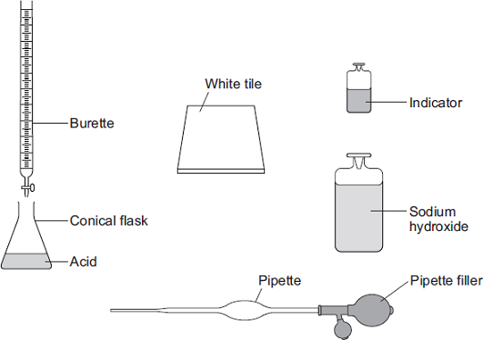
Describe how the student should use this equipment to find the volume of sodium hydroxide solution that reacts with a known volume of acid.
Include any measurements the student should make.
Do not describe how to do any calculations.
_______________________________________________________________________
_______________________________________________________________________
_______________________________________________________________________
_______________________________________________________________________
_______________________________________________________________________
_______________________________________________________________________
_______________________________________________________________________
_______________________________________________________________________
_______________________________________________________________________
_______________________________________________________________________
_______________________________________________________________________
_______________________________________________________________________
_______________________________________________________________________
_______________________________________________________________________
_______________________________________________________________________
(Total 6 marks)
Q7.
Magnesium reacts with steam to produce hydrogen gas and magnesium oxide.
A teacher demonstrated the reaction to a class. The figure below shows the apparatus the teacher used.
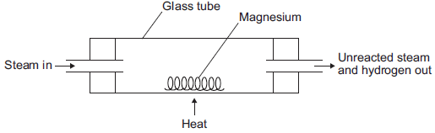
(a) (i) The hydrogen produced was collected.
Describe how to test the gas to show that it is hydrogen.
Test __________________________________________________________
______________________________________________________________
Result ________________________________________________________
______________________________________________________________
(2)
(ii) Explain why the magnesium has to be heated to start the reaction.
______________________________________________________________
______________________________________________________________
______________________________________________________________
______________________________________________________________
(2)

(b) The equation for the reaction is:
Mg(s) + H₂O(g) MgO(s) + H₂(g)
(i) The teacher used 1.00 g of magnesium.
Use the equation to calculate the maximum mass of magnesium oxide produced.
Give your answer to three significant figures.
Relative atomic masses (A _{r}): O = 16; Mg = 24
______________________________________________________________
______________________________________________________________
______________________________________________________________
______________________________________________________________
Maximum mass = ____________________ g
(3)
(ii) The teacher’s demonstration produced 1.50 g of magnesium oxide.
Use your answer from part (b)(i) to calculate the percentage yield.
If you could not answer part (b)(i), use 1.82 g as the maximum mass of magnesium oxide. This is not the answer to part (b)(i).
______________________________________________________________
Percentage yield = ____________________ %
(2)
(iii) Give one reason why the percentage yield is less than 100%.
______________________________________________________________
______________________________________________________________
______________________________________________________________
(1)
(Total 10 marks)

Q8.
The Haber Process is used to produce ammonia from nitrogen and hydrogen.
The equation for the reaction is:
N₂ + 3H₂ ⇌ 2NH₃
(a) An ammonia molecule has the formula NH₃
How many atoms are there in one molecule of ammonia?
Tick (✔) one box.

2 |  |  | 3 |  |  | 4 |  |  | 6
(1)
(b) What does the symbol ⇌ mean?
___________________________________________________________________
(1)
(c) Draw one line from each gas to the source of that gas.
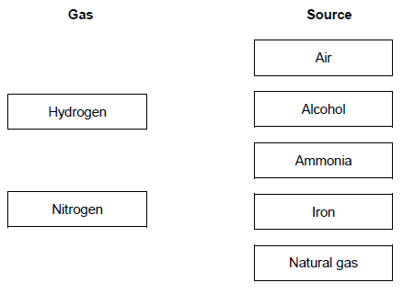
(2)

The diagram shows the Haber process.
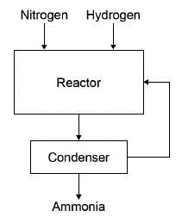
A mixture of ammonia, hydrogen and nitrogen gases leave the reactor.
Table 1 shows the boiling points of the gases.

Table 1
Gas | Boiling point in °C
Ammonia | – 33
Nitrogen | – 196
Hydrogen | – 253
(d) The mixture is cooled to a temperature at which only the ammonia condenses to a liquid.
Which temperature could be used?
Tick (✔) one box.

− 20 °C
− 40 °C
− 200 °C
− 260 °C
(1)

(e) What happens to the unreacted nitrogen?
Tick (✔) one box.

Collected and sold
Recycled to the reactor
Released into the air
Used as a catalyst
(1)
Ammonia from the Haber process can be used to produce fertilisers.
Table 2 gives information about two compounds used in fertilisers.

Table 2
Fertiliser | Compound | Cost in £ / kg
A | Potassium chloride | 0.24
B | Diammonium phosphate | 0.35
(f) What type of bonding is present in potassium chloride?
Tick (✔) one box.

Covalent
Ionic
Metallic
(1)

(g) Diammonium phosphate has the chemical formula (NH₄)₂HPO₄
Which two elements in (NH₄)₂HPO₄ improve agricultural productivity?
Tick (✔) two boxes.

Chlorine
Hydrogen
Nitrogen
Oxygen
Phosphorus
A farmer uses fertilisers A and B on a field with an area of 0.05 km²
(2)
(h) 50 kg of fertiliser A will cover an area of 0.01 km²
Calculate the cost of fertilising a field with an area of 0.05 km² with fertiliser A.
Use Table 2.
___________________________________________________________________
___________________________________________________________________
Cost = £ ____________________
(2)
(i) Fertiliser B is more expensive than fertiliser A.
Suggest why the farmer uses both fertilisers.
___________________________________________________________________
___________________________________________________________________
(1)
(Total 12 marks)

Q9.
Sodium hydroxide neutralises sulfuric acid.
The equation for the reaction is:
2NaOH + H₂SO₄ → Na₂SO₄ + 2H₂O
(a) Sulfuric acid is a strong acid.
What is meant by a strong acid?
___________________________________________________________________
___________________________________________________________________
___________________________________________________________________
(2)
(b) Write the ionic equation for this neutralisation reaction. Include state symbols.
___________________________________________________________________
(2)
(c) A student used a pipette to add 25.0 cm³ of sodium hydroxide of unknown concentration to a conical flask.
The student carried out a titration to find out the volume of 0.100 mol / dm³ sulfuric acid needed to neutralise the sodium hydroxide.
Describe how the student would complete the titration.
You should name a suitable indicator and give the colour change that would be seen.
___________________________________________________________________
___________________________________________________________________
___________________________________________________________________
___________________________________________________________________
___________________________________________________________________
___________________________________________________________________
___________________________________________________________________
___________________________________________________________________
___________________________________________________________________
___________________________________________________________________
(4)

(d) The student carried out five titrations. Her results are shown in the table below.

 | Titration 1 | Titration 2 | Titration 3 | Titration 4 | Titration 5
Volume of 0.100 mol / dm³ sulfuric acid in cm³ | 27.40 | 28.15 | 27.05 | 27.15 | 27.15
Concordant results are within 0.10 cm³ of each other.
Use the student’s concordant results to work out the mean volume of 0.100 mol / dm³ sulfuric acid added.
___________________________________________________________________
___________________________________________________________________
___________________________________________________________________
___________________________________________________________________
Mean volume = _____________________________ cm³
(2)
(e) The equation for the reaction is:
2NaOH + H₂SO₄ → Na₂SO₄ + 2H₂O
Calculate the concentration of the sodium hydroxide.
Give your answer to three significant figures.
___________________________________________________________________
___________________________________________________________________
___________________________________________________________________
___________________________________________________________________
___________________________________________________________________
___________________________________________________________________
___________________________________________________________________
Concentration = _______________________ mol / dm³
(4)
(f) The student did another experiment using 20 cm³ of sodium hydroxide solution with a concentration of 0.18 mol / dm³.
Relative formula mass (M_{r}) of NaOH = 40
Calculate the mass of sodium hydroxide in 20 cm³ of this solution.
___________________________________________________________________
___________________________________________________________________
___________________________________________________________________
___________________________________________________________________
Mass = ________________ g
(2)
(Total 16 marks)
Q10.
Nitrogen and hydrogen react to produce ammonia in the Haber process.
Figure 1 shows the Haber process.
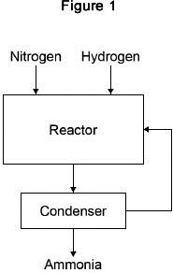
A gaseous mixture of ammonia, hydrogen and nitrogen leaves the reactor.
Table 1 shows the boiling points of the gases.

Table 1
Gas | Boiling point in °C
Ammonia | −33
Nitrogen | −196
Hydrogen | −253
(a) Suggest how ammonia is separated from the other gases.
___________________________________________________________________
___________________________________________________________________
___________________________________________________________________
___________________________________________________________________
___________________________________________________________________
(2)
(b) What happens to the unreacted hydrogen and nitrogen?
___________________________________________________________________
___________________________________________________________________
(1)
The equation for the reaction is:
N₂(g) + 3H₂(g) ⇌ 2NH₃(g)
The forward reaction is exothermic.
(c) Calculate the volume of ammonia produced from the complete reaction of 825 dm ³ of hydrogen.
___________________________________________________________________
___________________________________________________________________
___________________________________________________________________
___________________________________________________________________
Volume of ammonia = ____________________ dm ³
(2)
(d) The Haber process uses a temperature of 450 °C and a pressure of 200 atmospheres.
Why are these conditions used?
Tick two boxes.

A higher pressure is maintained using less energy
A higher temperature would increase the equilibrium yield
A lower pressure would decrease the equilibrium yield
A lower temperature would make the reaction too slow
There are more product molecules than reactant molecules
(2)

Most of the ammonia produced is used to make fertilisers.
Table 2 shows information about compounds used as fertilisers.

Table 2
Compound | Formula | Cost in £ / tonne
A | NH₄NO₃ | 220
B | (NH₄)₂HPO₄ | 350
C | KCl | 235
(e) Which element in compound A improves agricultural productivity?
___________________________________________________________________
(1)
(f) Which two compounds can be mixed to make a fertiliser containing three elements that improve agricultural productivity?
Give a reason why you have chosen these compounds.
Compounds ___________ and ___________
Reason ____________________________________________________________
___________________________________________________________________
(2)
(g) Figure 2 shows a flow chart for the production of compounds B and C.
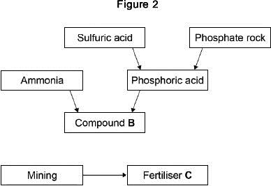
Suggest two possible reasons for the difference in cost between compounds B and C.
1. _________________________________________________________________
___________________________________________________________________
2. _________________________________________________________________
___________________________________________________________________
(2)
(Total 12 marks)

Mark schemes
Q1.
(a) 1
must be in this order
1
very small
accept negligible, 1 / 2000
allow zero
1
(b) The mass number
1
(c) C
1
(d) (i) 2
1
(ii) 3
1
(e) (i) 28
1
(ii) 42.9
accept ecf from (e)(i)
accept 42 - 43
1
(f) (i) 0.9
1
(ii) any one from:
• accurate
• sensitive
• rapid
• small sample.
1
[10]
Q2.
(a) produces H⁺ / hydrogen ions in aqueous solution
1
(but is) only partially / slightly ionised
1
(b) indicator changes colour
1
from blue to yellow
allow from blue to green
1
(when) the acid and alkali are (exactly) neutralised
or
(when) no excess of either acid or alkali
1
(c) pipette measures one fixed volume (accurately)
1
(but) burette measures variable volumes (accurately)
1
(d) 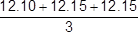
1
(mean titre =) 12.13(3) (cm ³)
1
(moles NaOH = conc × vol) = 0.00255
1
(moles citric acid = moles NaOH) = 0.00085
1
(conc acid = moles / vol) = 0.0701 (mol / dm ³)
allow ecf from steps 1, 2, 3 and / or 4
allow an answer of 0.0701 (mol / dm ³) without working for 1 mark only
1
[12]
Q3.
(a) add excess copper carbonate (to dilute hydrochloric acid)
accept alternatives to excess, such as ‘until no more reacts’
1
filter (to remove excess copper carbonate)
reject heat until dry
1
heat filtrate to evaporate some water or heat to point of crystallisation
accept leave to evaporate or leave in evaporating basin
1
leave to cool (so crystals form)
until crystals form
1
must be in correct order to gain 4 marks
(b) M_{r} CuCl₂ = 134.5
correct answer scores 4 marks
1
moles copper chloride = (mass / M_{r} = 11 / 134.5) = 0.0817843866
1
M_{r} CuCO₃= 123.5
1
Mass CuCO₃ (=moles × M₂= 0.08178 × 123.5) = 10.1(00)
1
accept 10.1 with no working shown for 4 marks
(c)
or
11.0 × 0.791
1
8.70 (g)
1
accept 8.70(g) with no working shown for 2 marks
(d) Total mass of reactants = 152.5
1
134.5
152.5
allow ecf from step 1
1
88.20 (%)
1
allow 88.20 with no working shown for 3 marks
(e) atom economy using carbonate lower because an additional product is made or carbon dioxide is made as well
allow ecf
1
[14]
Q4.
(a) in a closed system
1
the rate of the forward and backward reactions are equal
1
(b) concentration increases
1
(because) reaction / equilibrium moves to the left / reactant side
1
(since the) reverse reaction is exothermic
allow (so that) temperature increases
1
(c) becomes blue
1
(because) reaction / equilibrium moves to the right / product side
1
(so) concentration of blue cobalt compound increases
allow (so that) concentration of hydrochloric acid decreases
1
(d) (cobalt has) ions with different charges
allow (cobalt is a) transition metal
1
(e) Co³⁺
1
(f) they allow reactions to reach equilibrium more quickly
1
they provide a different reaction pathway
1
(g) 13H₂ + 6CO → C₆H₁₄ + 6H₂O
allow multiples
1
(h) C₈H₁₈
1
(i) curve below printed curve
do not accept different reactant or product levels
1
vertical arrow from reactant level to peak of printed curve
1
an answer of:
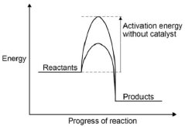
scores 2 marks
[16]
Q5.
(a) left hand: (conical) flask
do not accept round bottomed
flask or container which is not a flask
1
right hand: beaker / trough
accept plastic box
1
(b) (i) 157
1
(ii) all calcium carbonate used up or reaction stopped
do not accept all acid used up
1
(c) (i) 0.007(272727…)
correct answer with or without working gains 2 marks
if answer incorrect, allow (0.32 / 44) for 1 mark
2
(ii) 0.007(272727…)
allow ecf from (c)(i)
1
(iii) (M_{r} = mass / moles = 1 / 0.00727…) = 137.5 or 138
allow ecf from (c)(ii)
if use 0.00943 moles then = 106
if use 0.007 allow 143 (142.857)
1
(iv) (138) – 60 (= 78)
23 / 85
1
(78 / 2) = 39
1
potassium
sodium / rubidium
identity of metal ecf on A_{r}, but must be Group 1
If no working max 1 mark
1
(d) (i) (relative atomic mass) would decrease
1
because the mass lost greater
1
so moles carbon dioxide larger or moles metal carbonate greater
1
(ii) no change
1
because the acid (already) in excess
1
so the amount carbon dioxide lost is the same
1
[17]
Q6.
Marks awarded for this answer will be determined by the Quality of Written Communication (QWC) as well as the standard of the scientific response. Examiners should also refer to the information in the Marking guidance.
0 marks
No relevant content.
Level 1 (1-2 marks)
There is a simple description of using some of the equipment.
Level 2 (3-4 marks)
There is a description of an experimental method involving a measurement, or including addition of alkali to acid (or vice versa).
Level 3 (5-6 marks)
There is a description of a titration that would allow a successful result to be obtained.
Examples of chemistry points made in the response could include:
• acid in (conical) flask
• volume of acid measured using pipette
• indicator in (conical) flask
• sodium hydroxide in burette
• white tile under flask
• slow addition
• swirling
• colour change
• volume of sodium hydroxide added
Extra information
• allow acid in the burette to be added to sodium hydroxide in the (conical) flask
• allow any specified indicator
colour change need not be specified
[6]
Q7.
(a) (i) lit splint or ignite the gas
1
(squeaky) pop / explosion
1
(ii) because it provides energy (for the reaction)
1
to break bonds (in the reactants) or so the particles collide successfully
ignore reference to frequency or rate of collisions
because it provides the activation energy gains 2 marks
1
(b) (i) 1.67(g)
allow 1.66-1.68
correct answer (to 3 significant figures) with or without working gains 3 marks
if answer incorrect allow up to 2 marks for the following steps:
24 → 40
1.00 → 40 / 24
or
moles magnesium = 1 / 24 or 0.04(17)
multiply by 40
allow ecf from incorrect ratio or incorrect number of moles
3
(ii) if correct answer from part (b)(i) used
allow ecf from part (b)(i)
89.8 or 90
if 1.82 g used
82.4 or 82
correct answer with or without working gains 2 marks
if answer incorrect, allow the following for 1 mark:
1.50 / 1.67 (or their answer from part (b)(i))
if 1.82 g used: 1.50 / 1.82
2
(iii) any one from:
ignore measurement errors
• not all the magnesium reacted
allow the reaction may be reversible
• some of the magnesium oxide / product may have been left in the tube or may have been lost
ignore magnesium lost
• different / unexpected reaction
• magnesium not pure
1
[10]
Q8.
(a) 4
1
(b) reversible (reaction)
1
(c) 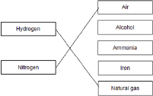
1
1
(d) −40 °C
1
(e) recycled to the reactor
1
(f) ionic
1
(g) nitrogen
1
phosphorus
1
(h) 0.24 × 50 × 5
allow £87.50
1
= £60
1
an answer of £60 scores 2 marks
(i) may need to use nitrogen, phosphorus and potassium
allow neither fertiliser has all the elements / nutrients needed.
[12]
Q9.
(a) (sulfuric acid is) completely / fully ionised
1
In aqueous solution or when dissolved in water
1
(b) H⁺(aq) + OH⁻(aq) → H₂O(l)
allow multiples
1 mark for equation
1 mark for state symbols
2
(c) adds indicator, eg phenolpthalein / methyl orange / litmus added to the sodium hydroxide
(in the conical flask)
do not accept universal indicator
1
(adds the acid from a) burette
1
with swirling or dropwise towards the end point or until the indicator just changes colour
1
until the indicator changes from pink to colourless (for phenolphthalein) or yellow to red
(for methyl orange) or blue to red (for litmus)
1
(d) titrations 3, 4 and 5
or
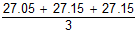
1
27.12 cm³
accept 27.12 with no working shown for 2 marks
1
allow 27.1166 with no working shown for 2 marks
(e) Moles H₂SO₄ = conc × vol = 0.00271
allow ecf from 8.4
1
Ratio H₂SO₄:NaOH is 1:2
or
Moles NaOH = Moles H₂SO₄ × 2 = 0.00542
1
Concentration NaOH = mol / vol = 0.00542 / 0.025 = 0.2168
1
0.217 (mol / dm³)
accept 0.217 with no working for 4 marks
1
accept 0.2168 with no working for 3 marks
(f) × 0.18 = no of moles
or
0.15 × 40 g
1
0.144 (g)
1
accept 0.144g with no working for 2 marks
[16]
Q10.
(a) cool
1
to −34 °C
allow temperatures below −34 °C but above −196 °C
1
(b) recycled (to the reactor)
1
(c) 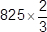
1
= 550 (dm ³)
1
an answer of 550 (dm ³) scores 2 marks
(d) a lower pressure would decrease the equilibrium yield
1
a lower temperature would make the reaction too slow
1
(e) nitrogen / N
1
(f) B and C
1
contain nitrogen, phosphorus and potassium
1
(g) (B)
any two from:
• more stages
• uses more energy
• uses more raw materials
• takes longer
allow converse for C
2
[12]

